CSS GENDER STUDIES
T4KB
The Knowledge Base
Topic 4 · Gender and Development — every theory, approach and critique, taught from zero
WHAT THIS DOCUMENT GIVES YOU
◆ Syllabus Head V taught from zero in simple English — the heaviest topic in the paper, asked in every year
◆ Colonial and capitalist perspectives of gender, and the thesis that development is the new name of coloniality
◆ A gender analysis of modernisation, dependency, world-system and structural-functionalist theory
◆ WID, WAD and GAD
◆ Moser's needs and roles, Kabeer's empowerment, gender mainstreaming
◆ The gender critique of structural adjustment
◆ globalisation and "gendered globalisation"
◆ climate change
◆ the MDGs and SDGs
◆ Evidence and Pakistani examples inside every point, diagrams, today's debates, the record and five likely questions
◆ About 125 MCQ-style one-liners, every past MCQ on the topic, and a detailed revision sheet
Federal Public Service Commission · CSS Competitive Examination · Optional paper, 100 marks
Written for CE-2027 onwards · Record: CE-2016 to CE-2026 · Facts current to September 2026

Contents
HOW TO BUILD THE CONTENTS
The contents list below fills itself in. When Word asks "This document contains fields that may refer to other files. Update the fields?", click Yes.
If it does not ask: right-click the grey contents area → Update Field → Update entire table → OK. On a Mac, Control-click the same area. Or press Ctrl + A, then F9 (Windows), to update every field at once. Repeat after any edit, before you export to PDF.

Right-click here and choose Update Field to build the contents.

How to Use This Document

What this topic covers
Topic 4 is syllabus Head V — Gender and Development. It is the heaviest topic in the paper: 17.5 visits in eleven papers, and at least one question every year from 2016 to 2026. It has four syllabus lines:
1. colonial and capitalist perspectives of gender;
2. a gender analysis of development theories — modernisation, world-system, dependency and structural functionalism;
3. the WID, WAD and GAD approaches, and the gender critique of structural adjustment;
4. globalisation and gender.
The examiner has added two newer lines: climate change (2026) and the claim that "development is the new name of coloniality" (2024). This document teaches all of them, with the global goals (MDGs and SDGs) as a final chapter.
IN SIMPLE WORDS
Development means making people's lives better — more income, health, education, freedom. Gender and Development asks a simple question: better for whom? A new road, a new factory or a loan from the IMF can help men and harm women, or the other way round. This topic teaches you how to see the difference.

How this document is built
1. Part Zero gives you the words of the topic, the question "development for whom?", and the whole topic on one diagram.
2. Part One has fifteen chapters: development itself (1); the colonial and capitalist perspectives (2–3); four development theories and a comparison (4–8); WID, WAD and GAD (9–11); structural adjustment (12); globalisation (13); climate (14); and the global goals (15).
3. Part Two sets out today's debates.
4. Part Three lists every past question, what the record shows, and five likely questions.
5. Part Four is a bank of about 125 numbered one-liners, followed by every past MCQ on the topic.
6. Part Five is the revision sheet — the whole topic in a few pages, every word explained.

Part Zero — The ABC of Topic 4

0.1 The words of this topic
Table 1 · The key terms of Topic 4 (★ = you must be able to define it in one sentence).
Term | Simple meaning, with an example
Development ★ | Improvement in people's lives — income, health, education, freedom and choice. Not only GDP growth.
GDP | Gross Domestic Product — the value of goods and services produced in a country in a year. It ignores unpaid work.
Human development | Widening people's choices and capabilities (Mahbub ul Haq and Amartya Sen; UNDP Human Development Report, 1990).
Colonialism ★ | Rule of one country over another, for the ruler's benefit. British rule in India, 1757/1858–1947.
Coloniality | The patterns of power created by colonialism that continue after independence — in knowledge, economy and gender (Quijano, Lugones).
Capitalism ★ | An economy of private ownership, markets and wage labour, driven by profit.
Modernisation theory ★ | Poor countries develop by becoming like the West — industry, cities, "modern" values (Rostow, 1960).
Dependency theory ★ | Poor countries are kept poor by rich ones through unequal trade (Frank, Prebisch).
World-system theory ★ | The world economy is one system of core, semi-periphery and periphery (Wallerstein, 1974).
Structural functionalism ★ | Society is a system of parts that keep it stable; men's and women's roles are "functional" (Parsons).
WID ★ | Women in Development (1970s): bring women into development projects (Boserup, 1970).
WAD ★ | Women and Development (late 1970s): women are already in development, but on unequal, exploitative terms.
GAD ★ | Gender and Development (1980s): change unequal power relations between women and men.
Practical gender needs ★ | Immediate needs arising from women's current roles — water, food, health care (Moser, from Molyneux).
Strategic gender interests ★ | Long-term interests in changing women's position — land rights, laws against violence, political power.
Triple role | Women's productive, reproductive and community-managing work (Moser).
Empowerment ★ | Gaining the ability to make strategic life choices where it was denied (Kabeer, 1999).
Gender mainstreaming ★ | Assessing every policy for its effects on women and men (Beijing, 1995).
Gender budgeting | Analysing a government budget for its effects on women and men.
Structural Adjustment Programmes (SAPs) ★ | IMF/World Bank loan conditions from the 1980s — cut spending, privatise, liberalise trade.
Globalisation ★ | The growing interdependence of societies across the world (MCQ 2023).
Feminisation of labour | More women in paid work, often in low-paid, insecure jobs (Standing, 1989).
Global care chain | Poor women migrate to care for richer families' children, leaving their own children with others (Hochschild, 2000).
Export processing zone | An area where factories producing for export get tax and labour-law concessions.
Informal sector | Work outside labour laws and social security — home-based work, domestic work, street vending.
Unpaid care work | Cooking, cleaning, caring for children, the sick and the old, done without pay — mostly by women.
Feminist economics | Economics that counts unpaid work and studies how economies affect women and men differently.
Ecofeminism | Links the domination of women with the domination of nature (d'Eaubonne, 1974).
Feminist environmentalism | Women's link to nature comes from their material work, not biology (Agarwal, 1992).
GDI / GEM / GII | UNDP's gender indices: Gender Development Index and Gender Empowerment Measure (1995); Gender Inequality Index (2010).
MDGs / SDGs | Millennium Development Goals (2000, 8 goals) and Sustainable Development Goals (2015, 17 goals; SDG 5 = gender equality).
Smart economics | The World Bank's argument that gender equality is good because it raises growth (WDR 2012).

0.2 Development for whom?
EXAMPLE
In several African countries, rice-development projects gave new seeds, training, credit and machines to men, because planners assumed men were the farmers. In fact, women grew most of the rice. The men took over the land and the income; women lost their crops and their independence. The project "succeeded" in raising output — and made women poorer. Evidence of this kind — first set out systematically by the Danish economist Ester Boserup (1970) — began the whole field of gender and development.

The lesson is that development is never gender-neutral. Every policy — a dam, a tax, a loan condition, a factory — lands on a society where men and women have different work, property, time and power. Gender analysis asks four questions of any development plan:
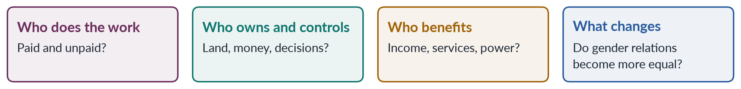
Figure 1 · Four questions gender analysis asks of any development plan.

0.3 The whole topic on one diagram
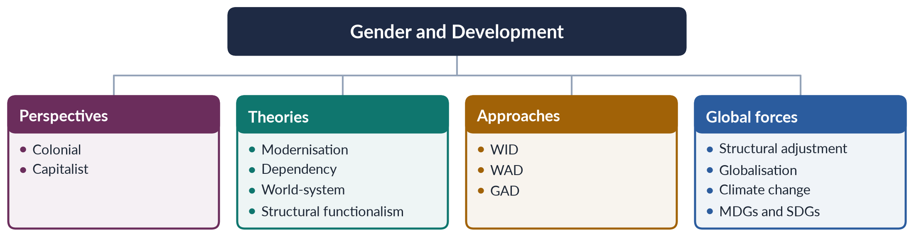
Figure 2 · Topic 4 at a glance.
EXAMINER'S EYE · HOW THE EXAMINER USES THIS TOPIC
Look at the command words: "critically review" (2016), "critically analyse" (2019, 2021, 2025, 2026), "give a critical gender analysis" (2024), "critically evaluate" (2025). The examiner does not want description alone. For every theory and approach, learn (1) what it says, (2) what it says or assumes about women, (3) its gender critique, and (4) a Pakistani example.

Part One — Gender and Development

Chapter 1 · What Development Is, and Why Gender Matters to It
Before you can analyse theories of development, you need to know what "development" means, how the idea changed, and how it is measured. This chapter gives you the base for the whole topic.

1.1 The birth of "development"
The modern idea of development began after the Second World War. In his inaugural address of 20 January 1949, US President Harry Truman announced a programme (his "Point Four") to make scientific and industrial progress available for the "improvement and growth of underdeveloped areas". Many scholars date the "development era" from this speech. It divided the world into "developed" and "underdeveloped" countries, and made the West the model for everyone else.
In the same years, colonies across Asia and Africa became independent — Pakistan and India in 1947 — and new governments looked for ways to grow quickly. Development became a national goal, a field of study and a huge international industry of agencies (the World Bank, founded 1944; UN agencies), donors and experts.

1.2 How the meaning of development changed
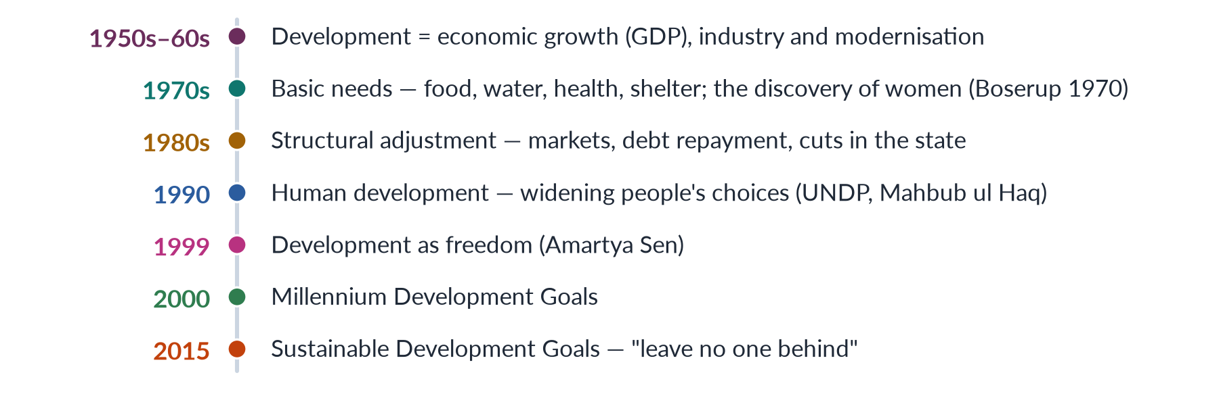
Figure 3 · How the meaning of development widened.
1. Growth. In the 1950s and 1960s development meant rising GDP: factories, dams, roads and cities. Benefits were expected to "trickle down" to everyone.
2. Basic needs. By the 1970s it was clear that growth often left the poor behind. The International Labour Organization and others called for meeting basic needs directly.
3. Adjustment. In the debt crisis of the 1980s, the IMF and World Bank made loans conditional on cutting state spending and opening markets (Chapter 12).
4. Human development. The Pakistani economist Mahbub ul Haq created the UNDP Human Development Report (1990) and the Human Development Index (HDI), which measures health, education and income together. He defined development as "enlarging people's choices".
5. Freedom. Amartya Sen (Development as Freedom, 1999) argued that development means expanding people's capabilities — their real freedom to live lives they value.
6. Sustainability. The SDGs (2015) joined economic, social and environmental goals under the promise to "leave no one behind".
✦ THINKER
Mahbub ul Haq · Pakistani economist · creator of the Human Development Report (1990)
"The basic purpose of development is to enlarge people's choices." Haq argued that income is a means, not an end; people's health, knowledge and freedom are what matter.
➜ A Pakistani contribution to world thinking on development — quote it in any definition.

1.3 Why gender matters to development
1. Women are half the population. Development that ignores half the people is not development.
2. Women's work is uncounted. GDP ignores unpaid care and subsistence work, most of it done by women. Marilyn Waring (If Women Counted, 1988) showed how national accounts make this work invisible.
3. Policies are not gender-neutral. Land reform, credit, technology, taxes and spending cuts affect women and men differently because they start from different positions.
4. Equality is a goal in itself. Gender equality is a human right (CEDAW, 1979; SDG 5) — not only a tool for growth.
5. Equality also helps development. Educated mothers have healthier children; women's income is more often spent on children's food and schooling; a larger labour force raises growth. The World Bank's World Development Report 2012: Gender Equality and Development called this "smart economics" (Chapter 3 discusses its critics).
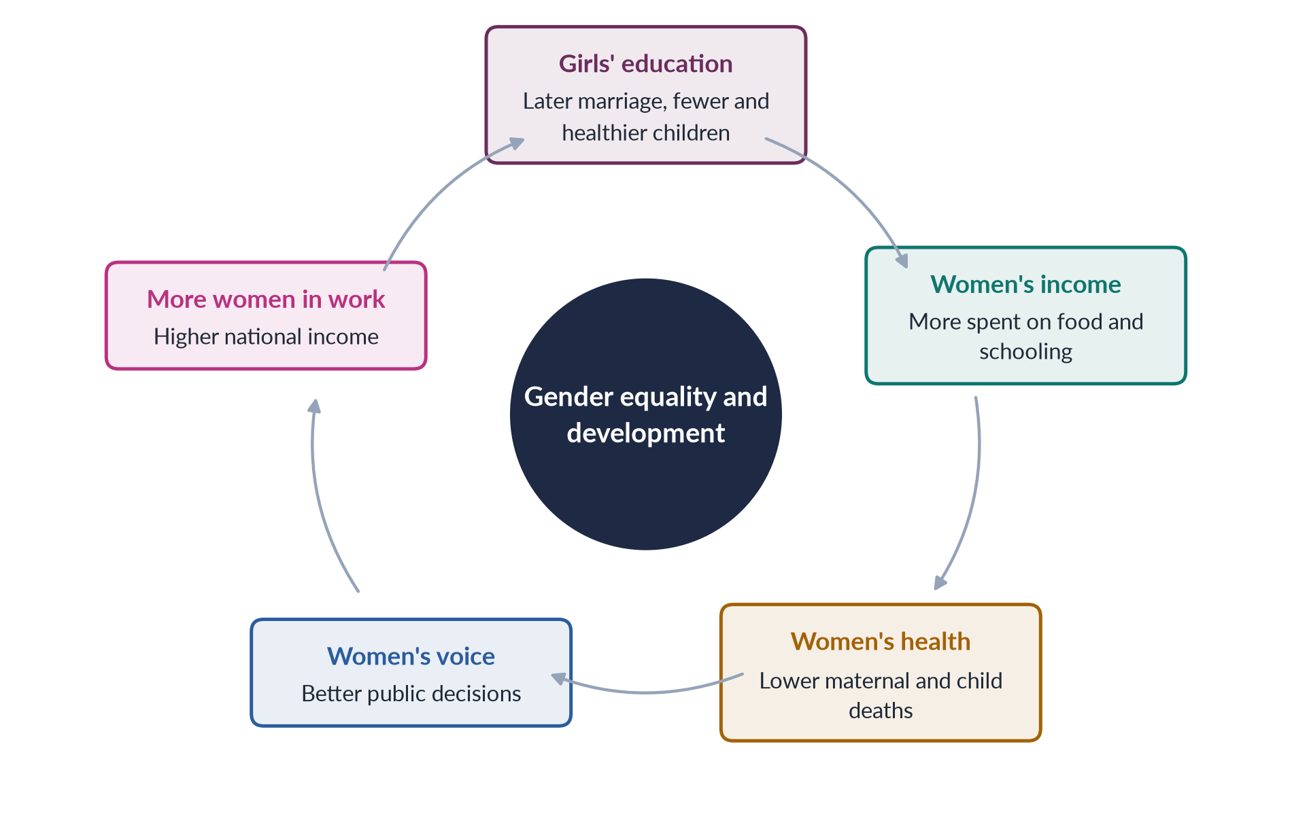
Figure 4 · Why gender equality and development reinforce each other.

1.4 Measuring gender and development
Table 2 · The main gender and development indices.
Index | Introduced | What it measures
Human Development Index (HDI) | UNDP, 1990 | Health, education and income — not a gender measure
Gender Development Index (GDI) | UNDP, 1995 | The HDI adjusted for gaps between women and men (revised in 2014 as a female-to-male HDI ratio)
Gender Empowerment Measure (GEM) | UNDP, 1995 | Women's share of seats, senior jobs and income; replaced in 2010
Gender Inequality Index (GII) | UNDP, 2010 | Reproductive health, empowerment and labour-market gaps
Global Gender Gap Index | World Economic Forum, 2006 | Economic participation, education, health and political empowerment

A 2025 MCQ asked which indicator measures gender inequality. The key point: the HDI is not a gender measure; the GDI, GEM and GII are gender-related measures, and the GII is the UN's measure of gender inequality.
✦ DATA
Pakistan's gender gap · World Economic Forum, Global Gender Gap Report 2026
Pakistan ranked 143rd of 145 economies, with 59.5% of its gender gap closed. It ranked 144th on economic participation and opportunity, 130th on educational attainment and 107th on political empowerment. In 2025 it had ranked last, 148th of 148.
➜ The economic gap is Pakistan's worst — which is why this topic matters so much for Pakistan.

1.5 Pakistan's development story in brief
- 1950s–60s: planned growth under the Planning Commission and the Harvard Advisory Group; Ayub Khan's "Decade of Development"; the Green Revolution in wheat and rice. Growth was high, but in 1968 Mahbub ul Haq warned that wealth was concentrated in about "22 families".
- 1970s: nationalisation under Z. A. Bhutto; basic-needs rhetoric ("roti, kapra aur makan").
- 1980s–90s: Gulf remittances; the first IMF adjustment programme (1988); debt and austerity.
- 2000s–2020s: services and remittances; social protection through the Benazir Income Support Programme (2008), which pays women; repeated IMF programmes; the 2022 floods.
- Women throughout: most working women remain in agriculture and the informal sector, much of it unpaid or home-based; female labour-force participation is only 24.4% (LFS 2024–25).
EXAMINER'S EYE · OPENING ANY TOPIC 4 ANSWER
Begin with a short definition of development that goes beyond GDP (Haq: "enlarging people's choices"; Sen: "freedom"), then say in one sentence why development is never gender-neutral. Add Pakistan's 2026 ranking and female labour-force participation. This gives every answer a strong, current base.

Chapter 2 · Colonial Perspectives of Gender
"How did the colonial era influence the status of women in the subcontinent?" (2020). "Write a detailed note on the colonial and capitalistic perspectives of gender" (2023, and again in 2024 with the thesis that "development is the new name of coloniality"). This chapter covers the colonial half; Chapter 3 the capitalist half.

2.1 What a "colonial perspective of gender" means
A colonial perspective of gender is the way colonial rulers saw, judged and changed gender relations in the societies they ruled — and the way colonised peoples responded. It has three parts:
1. The colonial gaze. Colonisers described colonised women as oppressed victims of "backward" cultures, and colonised men as cruel or effeminate. This justified colonial rule as a "civilising mission".
2. Colonial policies. Laws, land settlements, education and economic changes that reshaped women's lives — sometimes improving them, often harming them.
3. The nationalist response. Local reformers and nationalists, in turn, used women as symbols of national identity and tradition.
IN SIMPLE WORDS
Colonialism did not find "tradition" and leave it alone. It described local women in a way that justified its rule, changed their legal and economic position, and provoked a nationalist reply that also used women as symbols.

2.2 The colonial gaze: women as the measure of civilisation
- The British historian James Mill (The History of British India, 1817) argued that the condition of women is the measure of a society's civilisation, and judged Indian society low on this scale.
- The American writer Katherine Mayo's Mother India (1927) portrayed Indian men as degenerate and women as helpless victims of child marriage and seclusion; it was used to argue that Indians were unfit for self-rule. Gandhi called it "a drain inspector's report".
- The theorist Gayatri Chakravorty Spivak ("Can the Subaltern Speak?", 1988) summed up the colonial attitude to sati as "White men are saving brown women from brown men". In the debate between British officials and Indian elites, the widow herself was never heard.
- The historian Lata Mani (Contentious Traditions, 1998) showed that in the sati debate women were "neither subjects nor objects but, rather, the ground" on which colonial and indigenous men argued about tradition.

2.3 Colonial laws and reforms in British India
Table 3 · Colonial laws that shaped women's lives in British India.
Year | Law or policy | Effect on women
1829 | Bengal Sati Regulation | Banned widow burning after Raja Ram Mohan Roy's campaign
1856 | Hindu Widows' Remarriage Act | Allowed Hindu widows to remarry (Vidyasagar's campaign) — but they lost their late husband's property
1860 | Indian Penal Code | A uniform criminal code; its adultery section (497) punished only the man and treated the wife as the husband's property
1864–68 | Contagious Diseases and Cantonment Acts | Forced medical examination and registration of women suspected of prostitution near army bases
1870 | Female Infanticide Prevention Act | Aimed at female infanticide in north India
1871 | Criminal Tribes Act | Labelled whole communities, including hijras ("eunuchs"), as criminal
1872 | Punjab Laws Act | Made custom the first rule in matters such as inheritance, so many Muslim women lost the shares Islamic law gave them
1891 | Age of Consent Act | Raised the age of consent for girls from 10 to 12
1929 | Child Marriage Restraint Act (Sarda Act) | Set minimum marriage ages
1937 / 1939 | Shariat Application Act; Dissolution of Muslim Marriages Act | Applied Muslim personal law; gave Muslim women grounds for judicial divorce

2.4 How colonialism changed women's lives — four channels

(1) Law: codifying "tradition"
The British ruled personal matters — marriage, divorce, inheritance — by religious and customary law, which they collected and codified with the help of male religious scholars and landowners. This turned flexible, varied practices into rigid written rules, often the most patriarchal versions. "Anglo-Muhammadan law" and the Punjab Laws Act 1872, which put custom before Islamic law, left many women in Punjab without the inheritance Islam allowed them.

(2) Land and property: registering men
Colonial land settlements recorded land in the names of male heads of households. Women's customary rights of use — to graze animals, gather fuel, cultivate family plots — were not recorded and were easily lost. This laid the base of today's gap in land ownership.

(3) Economy: new work, lost work
Colonial trade destroyed some crafts in which women worked (hand-spinning and weaving lost out to British machine cloth) and drew labour into cash crops, plantations and army cantonments. Men were drawn into wage work and the army; women's household and subsistence work lost value.

(4) Education and reform
Missionaries and the colonial state opened some girls' schools; Indian reformers opened many more. Education created a small class of educated women who later led women's organisations — including APWA and the women of the Pakistan Movement (Topic 3).
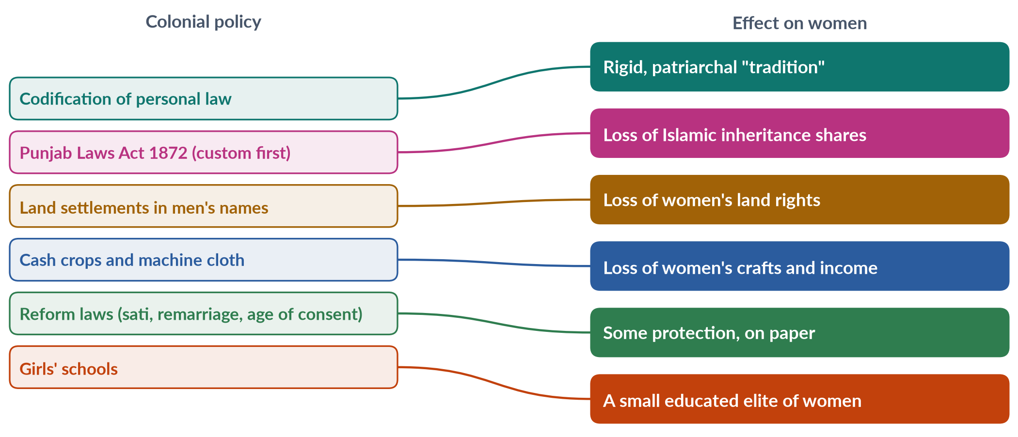
Figure 5 · Colonial policies and their effects on women.

2.5 The nationalist response
The historian Partha Chatterjee ("The Nationalist Resolution of the Women's Question", 1989) argued that Indian nationalists divided life into an outer, material world (where the West could be copied) and an inner, spiritual world of home and family (which must stay "Indian"). Women became guardians of the inner world — educated, but modest and devoted to the home. This "new woman" was different from both the Western woman and the "backward" traditional woman.
Muslim reformers followed a similar path: Nazir Ahmad's Mirat-ul-Uroos (1869) and Mumtaz Ali's Huquq-un-Niswan (1898) promoted women's education within Islamic and family values. The result was a lasting link between women, honour and national or religious identity.

2.6 Assessment: did colonialism help or harm women?
BALANCED VIEW · THE COLONIAL LEGACY FOR WOMEN IN THE SUBCONTINENT
• Gains: laws against sati and female infanticide; widow remarriage; age of consent and child-marriage laws; girls' schools; a legal basis for Muslim women's divorce (1939).
• Losses: codification of the most patriarchal readings of custom; loss of inheritance (Punjab 1872) and land rights; criminalisation of hijras (1871); control of women's bodies (Contagious Diseases Acts); use of women to justify colonial rule.
• Limits of the gains: reforms were few, often unenforced, and usually came from Indian reformers, not British initiative.
➜ The colonial era did not simply liberate or oppress women. It rearranged patriarchy — replacing some local controls with new colonial ones — and left laws and property patterns Pakistan still lives with.

2.7 The colonial legacy in Pakistan today
- The Penal Code of 1860 remains the base of Pakistan's criminal law; parts of it have been amended many times.
- The Child Marriage Restraint Act 1929 remained the national law until provinces and Islamabad raised the age (Sindh 2013; Islamabad 2025, age 18).
- Women's low land ownership and the denial of inheritance by custom echo colonial land records and the Punjab Laws Act.
- The treatment of khawaja siras carries the stigma of the Criminal Tribes Act.
- Debates over women as symbols of national and religious identity — in dress, the Aurat March, textbooks — continue the nationalist response.
EXAMINER'S EYE · ANSWERING 2020: "HOW DID THE COLONIAL ERA INFLUENCE THE STATUS OF WOMEN?"
Use four channels as headings — law, land, economy, education — each with a dated law or policy and its effect. Add the colonial gaze (James Mill, Mayo, Spivak) and the nationalist response (Chatterjee). End with a balanced assessment and the legacy in Pakistan. Draw the mapping figure.

Chapter 3 · Capitalist Perspectives of Gender — and Development as Coloniality
"What are the capitalistic perspectives of gender? Explain" (2022); "Write a detailed note on the colonial and capitalistic perspectives of gender" (2023); and in 2024, "Throw light on the thesis that development is the new name of coloniality." This chapter answers all three.

3.1 What "capitalist perspectives of gender" means
Capitalism is an economic system based on private ownership, markets, wage labour and profit. "Capitalist perspectives of gender" are the ways of understanding how capitalism shapes — and is shaped by — gender relations. There are two broad perspectives:
1. The liberal (market) perspective: capitalism can free women by giving them jobs, income and independence from family control. Remove barriers, and markets will reward women's talent.
2. The critical (Marxist and socialist-feminist) perspective: capitalism depends on and deepens women's subordination — it profits from women's unpaid work at home and cheap work outside.
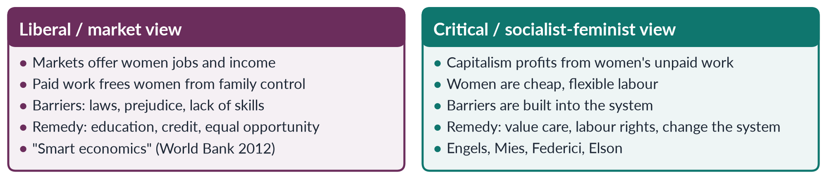
Figure 6 · Two capitalist perspectives of gender.

3.2 The critical perspective — key ideas

(1) Private property and the family
Friedrich Engels (The Origin of the Family, Private Property and the State, 1884) argued that women's subordination began with private property: men who owned herds and land wanted to pass them to their own sons, and so controlled women's sexuality through monogamy — "the world historical defeat of the female sex".

(2) The separation of home and work
Before industrial capitalism, most production happened in the household, where men and women both worked. Industrial capitalism moved production into factories, creating the "public" world of paid work (seen as men's) and the "private" world of unpaid domestic work (seen as women's). The ideology of separate spheres and the male "breadwinner" followed.

(3) Unpaid labour and social reproduction
Marxist feminists showed that housework produces the most important commodity of all — the worker — every day, for free (Benston, 1969; Dalla Costa and James, 1972). Capitalism depends on this social reproduction but does not pay for it (Topic 2).

(4) Cheap and flexible labour
Women are treated as a reserve army of labour and as "secondary earners", so employers pay them less and hire and fire them easily. Global capitalism seeks out young women for export factories because they are seen as cheap, docile and dexterous.

(5) Housewifisation
✦ THINKER
Maria Mies · *Patriarchy and Accumulation on a World Scale* (1986)
Mies studied the lace makers of Narsapur in India: women who made lace at home for world markets were counted as "housewives" doing leisure work, so they were paid very little while exporters profited. She called this "housewifisation" — defining women as housewives so their productive work can be cheapened. It links patriarchy, colonialism and capitalism into one system of accumulation.
➜ Use Mies for both 2022 and 2024: she joins the capitalist and colonial perspectives.

(6) Primitive accumulation and the witch-hunts
Silvia Federici (Caliban and the Witch, 2004) argued that the rise of capitalism in Europe involved the witch-hunts of the sixteenth and seventeenth centuries, which destroyed women's control over reproduction and healing and pushed them into unpaid domestic roles.

3.3 The liberal perspective — and its critics
The World Bank's World Development Report 2012: Gender Equality and Development argued that gender equality is "smart economics": educating women and employing them raises productivity and growth. Microfinance, girls' education and women's entrepreneurship programmes follow this view.
Critics (such as Sylvia Chant and Caroline Sweetman, 2012) replied that smart economics values women only as instruments of growth, not as rights-holders; it adds paid work to women's unpaid work without redistributing care; and it ignores power, violence and collective organisation.

3.4 Capitalism and gender in Pakistan
- Home-based work: millions of women stitch, embroider and pack at home for piece rates — Mies's "housewifisation" in action. Sindh's Home-Based Workers Act 2018 was Pakistan's first to recognise them.
- Textiles and garments: the export industry depends on low-paid workers, many of them women; the fire at Ali Enterprises, Karachi (11 September 2012), killed about 260 workers and exposed unsafe conditions in global supply chains.
- Agriculture: women's cotton-picking and livestock work is poorly paid or unpaid.
- Unpaid care: women's unpaid work in households is uncounted in GDP.
- Low participation: female labour-force participation is 24.4% (LFS 2024–25) — capitalism in Pakistan has drawn in fewer women than in Bangladesh or Sri Lanka.

3.5 Colonial and capitalist perspectives together
The colonial and capitalist perspectives are closely linked:
1. Colonialism was a form of capitalist expansion — trading companies such as the East India Company sought profit.
2. Both created a public/private split and a male breadwinner model.
3. Both extracted value from women's cheap or unpaid work — on plantations, in crafts, in homes.
4. Both used ideas of "civilisation" and "progress" to justify their power.
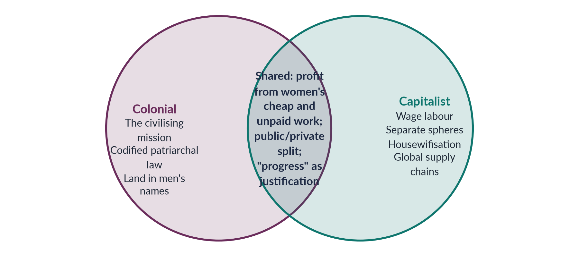
Figure 7 · How colonial and capitalist perspectives of gender overlap.

3.6 "Development is the new name of coloniality" (2024)

(1) Coloniality
✦ DEFINITION
Coloniality · from Aníbal Quijano
The Peruvian sociologist Aníbal Quijano (2000) distinguished colonialism (formal political rule, which ended) from coloniality (the patterns of power it created, which continue): racial hierarchies, a world economy centred on the West, and Western control of knowledge — what counts as "modern", "rational" and "developed".

✦ THINKER
María Lugones · "Heterosexualism and the Colonial/Modern Gender System" (2007)
Lugones argued that colonialism imposed a European gender system — rigid male/female binaries, the male-headed household and heterosexual norms — on colonised peoples, many of whom had different arrangements. She called this the coloniality of gender.

(2) The post-development critique
Arturo Escobar (Encountering Development, 1995) and Wolfgang Sachs (ed., The Development Dictionary, 1992) argued that "development" since Truman (1949) has been a discourse: it defines the South as "underdeveloped", makes Western experts the authorities, and turns local ways of life into "problems" to be fixed.

(3) The thesis applied to gender
1. The "Third World woman" as victim. Development reports often portray Southern women as poor, ignorant and oppressed — echoing the colonial gaze (Chandra Mohanty, "Under Western Eyes", 1984).
2. Experts from outside. Donors, consultants and international agencies set the agenda — the same pattern as colonial administrators.
3. Debt and conditions. Structural adjustment (Chapter 12) gave foreign lenders power over national budgets, cutting services women depend on.
4. Extraction continues. Global supply chains draw on cheap female labour in the South, as colonial trade drew on crafts and plantations.
5. Western gender models. Programmes may impose Western ideas of the family or of "empowerment" without asking local women.

(4) The counter-argument
BALANCED VIEW · IS DEVELOPMENT REALLY COLONIALITY?
• For the thesis: the power structures, the language ("underdeveloped", "beneficiaries") and the flows of profit and debt show continuity with colonial rule.
• Against: development has also brought vaccines, schools, lower maternal and child deaths and rising incomes; Southern governments and movements shape development themselves (Mahbub ul Haq's human development; DAWN, 1984); women in the South demand education, health and rights — these are not foreign impositions.
➜ The line to take: development can reproduce coloniality when it is imposed from outside and serves external interests; it becomes emancipatory when it is owned by local people, especially women, and when it addresses power, not only projects.

EXAMINER'S EYE · THE MODEL STRUCTURE FOR 2024
1. Introduction: define colonial and capitalist perspectives, and coloniality. 2. Colonial perspectives (gaze, laws, land, nationalist response). 3. Capitalist perspectives (Engels, separate spheres, unpaid labour, Mies). 4. Their links. 5. The thesis: Quijano, Lugones, Escobar, Mohanty — five ways development repeats coloniality, with Pakistani examples (IMF conditions, donor agendas, supply chains). 6. The counter-argument. 7. Conclusion: development must be decolonised, not abandoned. Draw the Venn figure.

Chapter 4 · A Gender Analysis of Modernisation Theory
"Explain the relevance of Modernization Theory and Dependency Theory to gender equality" (2019); "Modernization Theory blames internal cultural factors for women's subordination in the developing world. Discuss and elaborate" (2021); and "Give a critical gender analysis of development theories" (2024).

4.1 What modernisation theory says
✦ DEFINITION
Modernisation theory · the first theory of development (1950s–60s)
The view that poor countries are poor because they are "traditional", and will develop by passing through the same stages as the West — industrialisation, urbanisation, education, democracy and "modern" values. The obstacles are internal: traditional culture, religion, family structures and attitudes.
➜ Key words: tradition versus modernity, stages of growth, take-off, trickle-down, diffusion of Western values and technology.

✦ THINKER
W. W. Rostow · *The Stages of Economic Growth: A Non-Communist Manifesto* (1960)
Rostow described five stages through which every society passes: (1) traditional society; (2) preconditions for take-off; (3) take-off; (4) drive to maturity; (5) age of high mass consumption. Foreign aid, investment and technology could help poor countries "take off".
➜ The subtitle shows it was also a Cold War alternative to communism.

Other modernisation thinkers:
- Talcott Parsons contrasted "traditional" societies (based on family, status and emotion) with "modern" ones (based on achievement, universal rules and rationality).
- Daniel Lerner (The Passing of Traditional Society, 1958) studied the Middle East and argued that mass media and cities create "modern" personalities.
- Alex Inkeles and David Smith (Becoming Modern, 1974) measured "modern" attitudes in six developing countries.
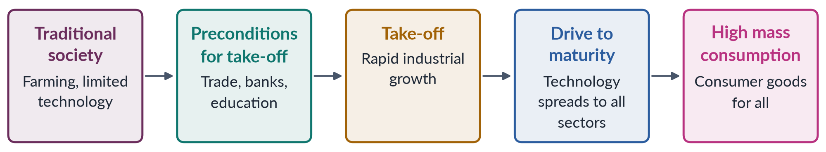
Figure 8 · Rostow's five stages of economic growth.

4.2 What modernisation theory said — and assumed — about women
1. Tradition oppresses women; modernity frees them. Purdah, early marriage, seclusion and large families were seen as features of "backward" culture that would fade as societies modernised.
2. Benefits trickle down. Growth would benefit women automatically through the family — through the male breadwinner.
3. Women as mothers. Development planners treated women mainly as mothers and housewives — targets of family planning, nutrition and home-economics programmes — not as producers.
4. The Western family as the model. The Western nuclear family, with a male breadwinner and a female homemaker, was the image of "modern" gender relations (Parsons — Chapter 7).

4.3 "Modernisation blames internal cultural factors" (2021)
The 2021 statement is correct as a description: modernisation theory located the causes of women's subordination inside developing societies — in their culture, religion and traditions — rather than in colonial history, global economics or the development process itself.
Examples of this "cultural" explanation:
- women's low education explained by parents' traditional attitudes;
- women's absence from paid work explained by purdah and family honour;
- high fertility explained by traditional values;
- the cure: education, media, urbanisation and exposure to Western values.

4.4 The gender critique of modernisation theory

(1) Boserup's evidence: modernisation often made women worse off
✦ THINKER
Ester Boserup · *Woman's Role in Economic Development* (1970)
Boserup showed that in many parts of Africa and Asia women were major farmers. Colonial and development policies gave land titles, new technology, training and credit to men, so women lost status and income as agriculture "modernised". She also contrasted female farming systems (hoe cultivation, common in Africa) with male farming systems (plough cultivation, common in Asia).
➜ The founding text of the WID approach (Chapter 9).

(2) It blames the victims' culture and ignores structures
By blaming "tradition", modernisation theory ignored colonial history, global trade, land ownership and state policy — the external and structural causes that dependency and world-system theories stress.

(3) It assumes the West is the model
Western societies also subordinated women (unequal pay, violence, the "feminine mystique"). Modernity brought new forms of patriarchy — the housewife ideal, beauty industries, the double burden — not simply freedom.

(4) Trickle-down did not reach women
Growth concentrated income in men's hands; women's unpaid work increased; benefits did not flow equally within households.

(5) "Tradition" is not fixed
Many "traditions" were reshaped by colonial rule (Chapter 2); and some local practices gave women rights that "modern" laws took away.

(6) It ignores women's agency
Women were treated as passive objects of modernisation, not as actors who resist, bargain and innovate.
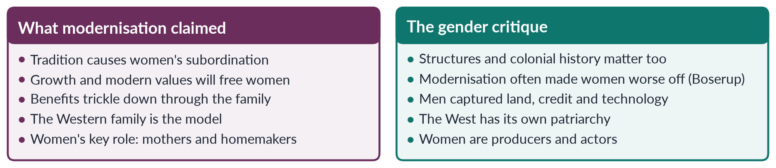
Figure 9 · Modernisation theory on women, and its gender critique.

4.5 Relevance of modernisation theory to gender equality today
The theory is not simply wrong. Education, urbanisation, mass media and paid work have clearly widened women's choices in many countries — as Pakistan's own rising girls' enrolment and the fall in fertility show. Some cultural practices (child marriage, honour killing, denial of inheritance) are major obstacles. The theory's weakness is to treat culture as the only cause and the West as the only model.
PAKISTAN ANGLE · MODERNISATION AND WOMEN IN PAKISTAN
• The Ayub era (1958–69) followed modernisation thinking: growth, industry and the Green Revolution. It also produced the Muslim Family Laws Ordinance 1961, a "modernising" reform of family law.
• The Green Revolution raised wheat and rice output, but machines, credit and new seeds went mostly to male landowners; many poor women lost paid agricultural work.
• Today, urbanisation, girls' education and mobile phones are widening women's opportunities — yet female labour-force participation is still only 24.4%, showing that modernisation alone is not enough without changes in structures (transport, childcare, safety, property, wages).

EXAMINER'S EYE · THE MODEL STRUCTURE FOR 2021
1. Introduction: define modernisation theory; Rostow (1960). 2. Its stages and assumptions. 3. What it said about women. 4. Elaborate the statement: the internal-cultural explanation with examples (purdah, early marriage, attitudes). 5. Evaluate: where the statement holds (real cultural obstacles). 6. Gender critique: Boserup; structures ignored; Western bias; trickle-down; invented tradition; agency. 7. Pakistan (Ayub era, Green Revolution, today). 8. Conclusion: culture matters, but so do structures and power. Draw the compare figure.

Chapter 5 · Dependency Theory and Gender
Dependency theory was the great challenge to modernisation. It appeared in 2019 ("the relevance of Modernization Theory and Dependency Theory to gender equality") and in the 2024 question on development theories.

5.1 What dependency theory says
✦ DEFINITION
Dependency theory · the Southern answer to modernisation (1950s–70s)
The view that poor countries are poor not because they are "traditional", but because they have been made dependent on rich countries through colonialism and unequal trade. The rich "centre" (or core) grows by extracting cheap raw materials and labour from the poor "periphery". Underdevelopment is not an early stage of development; it is a result of the same process that developed the West.
➜ Key words: centre/periphery, unequal exchange, surplus extraction, "development of underdevelopment", self-reliance.

The main thinkers:
- Raúl Prebisch and the UN Economic Commission for Latin America (from 1950) — the Prebisch–Singer thesis: the prices of the South's raw materials fall over time relative to the North's manufactured goods, so trade keeps the South poor.
- Andre Gunder Frank — "the development of underdevelopment" (1966): the periphery was underdeveloped by its links to the centre.
- Walter Rodney — How Europe Underdeveloped Africa (1972).
- Samir Amin — unequal exchange and "delinking".
- Fernando Henrique Cardoso and Enzo Faletto — Dependency and Development in Latin America (1969): "dependent development" is possible, but on unequal terms.
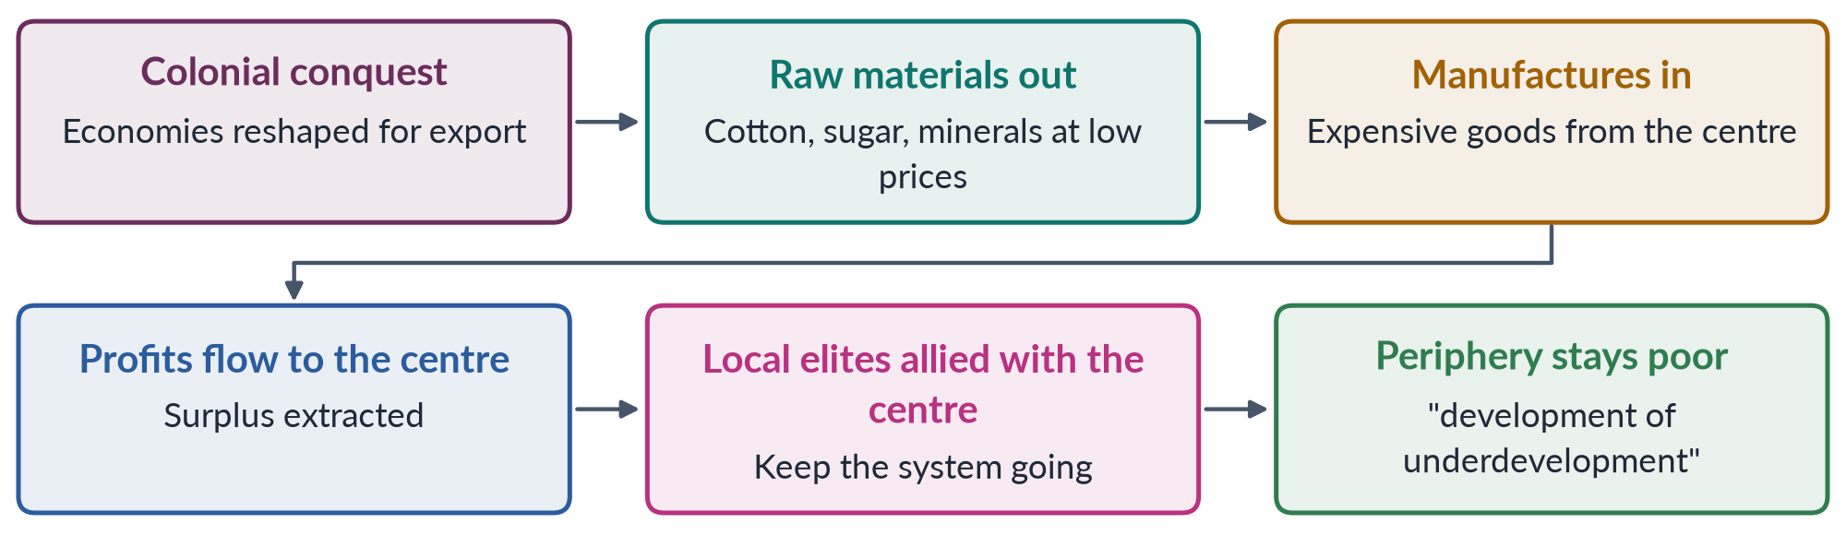
Figure 10 · How dependency theory explains underdevelopment.

5.2 Policy conclusions
Dependency theorists recommended import-substituting industrialisation (making at home what was imported), protection of local industry, state planning, South–South cooperation and, for radicals, breaking with world capitalism. These ideas shaped Latin America, parts of Africa and South Asia in the 1960s–70s, and the call for a New International Economic Order at the UN (1974).

5.3 What dependency theory offers gender analysis
1. Structures, not culture. It moves the explanation of women's poverty from "traditional culture" (modernisation) to global structures of trade and power.
2. Colonial history. It connects women's position to the colonial reshaping of economies (Chapter 2).
3. Exploitation of cheap labour. It explains why the periphery offers cheap labour — and, as feminists added, why that labour is increasingly female.
4. Class. It links gender to class and the alliance of local elites with foreign capital.

5.4 The gender critique of dependency theory

(1) Gender-blind
Classic dependency theory talked about nations and classes, not women and men. It did not ask who does the work inside the periphery's households, farms and factories.

(2) Women's unpaid work subsidises the system
Feminists added that the periphery's cheap exports depend on women's unpaid subsistence and care work, which lets employers pay wages too low to support a family (Maria Mies, 1986; the WAD approach — Chapter 10).

(3) Local patriarchy is ignored
By blaming the centre for everything, dependency theory overlooked local patriarchal structures — landlords, male household heads, religious authorities — which subordinate women whatever the global system.

(4) Male nationalist models
Many dependency-inspired states promoted male industrial workers and national self-reliance, while women's work in agriculture and the home remained unvalued.

(5) Empirical challenges
The rise of the "Asian tigers" (South Korea, Taiwan) through export-led growth — relying heavily on young women's factory labour — challenged the claim that ties to the world market always cause underdevelopment.
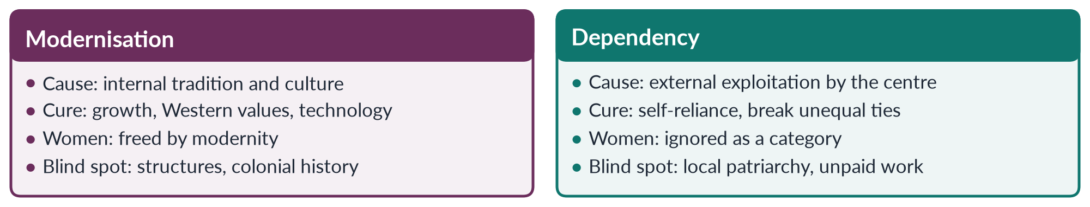
Figure 11 · Modernisation and dependency theory on women.

5.4a Feminist uses of dependency ideas
Feminist scholars in Latin America and South Asia used dependency theory to show a double dependency: countries of the periphery depend on the centre, and women within them depend on men. Helen Safa, studying women workers in Latin American factories, showed how export industries depended on women's cheap labour while local families still expected them to do all the housework. In South Asia, scholars linked the dowry economy, land concentration and migration to both global and local structures.
IN SIMPLE WORDS
Dependency theory explains why the country is poor. Feminists added why, within that poor country, women are poorer still — and why their unpaid work makes the whole export economy possible.

5.5 Relevance to gender equality
Dependency theory helps explain why:
- women in poor countries do the lowest-paid work in global chains (cotton picking, garment stitching, home-based work);
- debt and dependence on lenders lead to spending cuts that hurt women (Chapter 12);
- the terms of trade of commodity exporters — such as cotton — keep rural wages low.
But gender equality needs more than escaping dependence: it needs change in local gender relations too.
PAKISTAN ANGLE · DEPENDENCY AND WOMEN IN PAKISTAN
• Pakistan's economy still depends heavily on cotton and textiles; cotton-picking women earn very little for hard, seasonal work, and garment exports rely on low-paid labour.
• Repeated IMF programmes and external debt limit spending on health, education and social protection — services women rely on most.
• Yet local structures — feudal landholding, customary denial of inheritance, restrictions on women's mobility — also keep women poor. A full analysis needs both the dependency lens and a gender lens.

EXAMINER'S EYE · THE MODEL STRUCTURE FOR 2019
1. Introduction: two rival theories of development. 2. Modernisation — claims, stages, view of women. 3. Its relevance to gender equality, and its critique (Boserup). 4. Dependency — claims, thinkers, view of women. 5. Its relevance, and its gender critique. 6. Subordination in modern societies: what each theory explains and misses (culture vs structure; the double burden; cheap female labour). 7. Pakistan. 8. Conclusion: both culture and global structures matter — gender analysis joins them. Draw the compare figure.

Chapter 6 · World-System Theory and Gender
A 2019 MCQ asked who developed world-system theory (Immanuel Wallerstein). In 2025 the descriptive paper asked candidates to "critically evaluate the concept of 'gendered globalisation', focusing on World-System Theory and how the globalisation of capitalism has created new forms of patriarchal power that increase gender inequalities."

6.1 What world-system theory says
✦ THINKER
Immanuel Wallerstein · *The Modern World-System*, vol. 1 (1974)
Wallerstein argued that since the sixteenth century there has been a single capitalist world-economy, divided into three zones:
• the core — rich, industrial, high-wage countries that control finance and technology;
• the periphery — poor countries supplying raw materials and cheap labour;
• the semi-periphery — countries in between, which both exploit the periphery and are exploited by the core.
Surplus flows from periphery to core through unequal exchange. Countries can move between zones, but the system stays unequal.

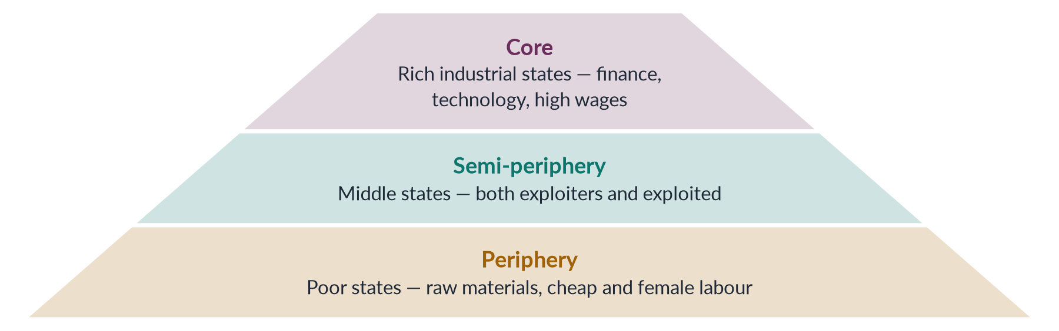
Figure 12 · Wallerstein's world-system.
How it differs from dependency theory:
1. It studies one world system, not pairs of countries.
2. It adds the semi-periphery, explaining how some countries (such as South Korea or China) rise.
3. It takes a long historical view, from the 1500s.

6.2 Adding gender: what the original theory missed
Like dependency theory, early world-system theory was largely gender-blind. Feminist scholars extended it in three ways.

(1) The household as the base of the system
Wallerstein himself, with Joan Smith (Creating and Transforming Households, 1992), argued that capitalism relies on households that combine wages with unpaid work, subsistence farming and petty trade. Because households survive on more than wages, employers can pay less than a living wage. The unpaid labour that fills the gap is mostly women's.

(2) Housewifisation on a world scale
Maria Mies (Patriarchy and Accumulation on a World Scale, 1986) argued that the world-system rests on three linked forms of exploitation: of nature, of colonies and of women. Women everywhere are defined as "housewives", so their work — at home or in export production — can be paid little or nothing.

(3) The global assembly line
From the 1970s, companies moved manufacturing to export processing zones in the periphery and semi-periphery, where they hired mainly young women — in electronics, garments and toys. Annette Fuentes and Barbara Ehrenreich (Women in the Global Factory, 1983) called this the global assembly line. Kathryn Ward (Women Workers and Global Restructuring, 1990) brought such research into world-system analysis.

6.3 "Gendered globalisation" (2025)
✦ DEFINITION
Gendered globalisation · the 2025 concept
The idea that globalisation — the integration of economies through trade, investment, finance and migration — is not gender-neutral: it relies on, reshapes and often deepens gender inequalities, while creating some new opportunities for women.

New forms of patriarchal power in the globalised world-system
1. Corporate patriarchy. Global brands and factory managers control women workers through low wages, long hours, surveillance and harassment — a workplace patriarchy added to the family's.
2. Feminisation of labour. Jobs once held by men become "women's jobs" as they are made flexible, informal and low-paid (Guy Standing, "Global Feminization through Flexible Labor", 1989).
3. Global care chains. Women from the periphery migrate to care for families in the core, leaving their own children with relatives — a transfer of care from poor to rich (Arlie Hochschild, 2000).
4. Debt and austerity. Core-controlled lenders impose spending cuts that shift the burden of care onto women (Chapter 12).
5. Commodification of bodies. Growth of global sex industries, trafficking, commercial surrogacy and beauty industries.
6. Cultural backlash. Rapid change can provoke local patriarchal reactions — tighter control over women's mobility, dress and sexuality in the name of protecting "our culture".
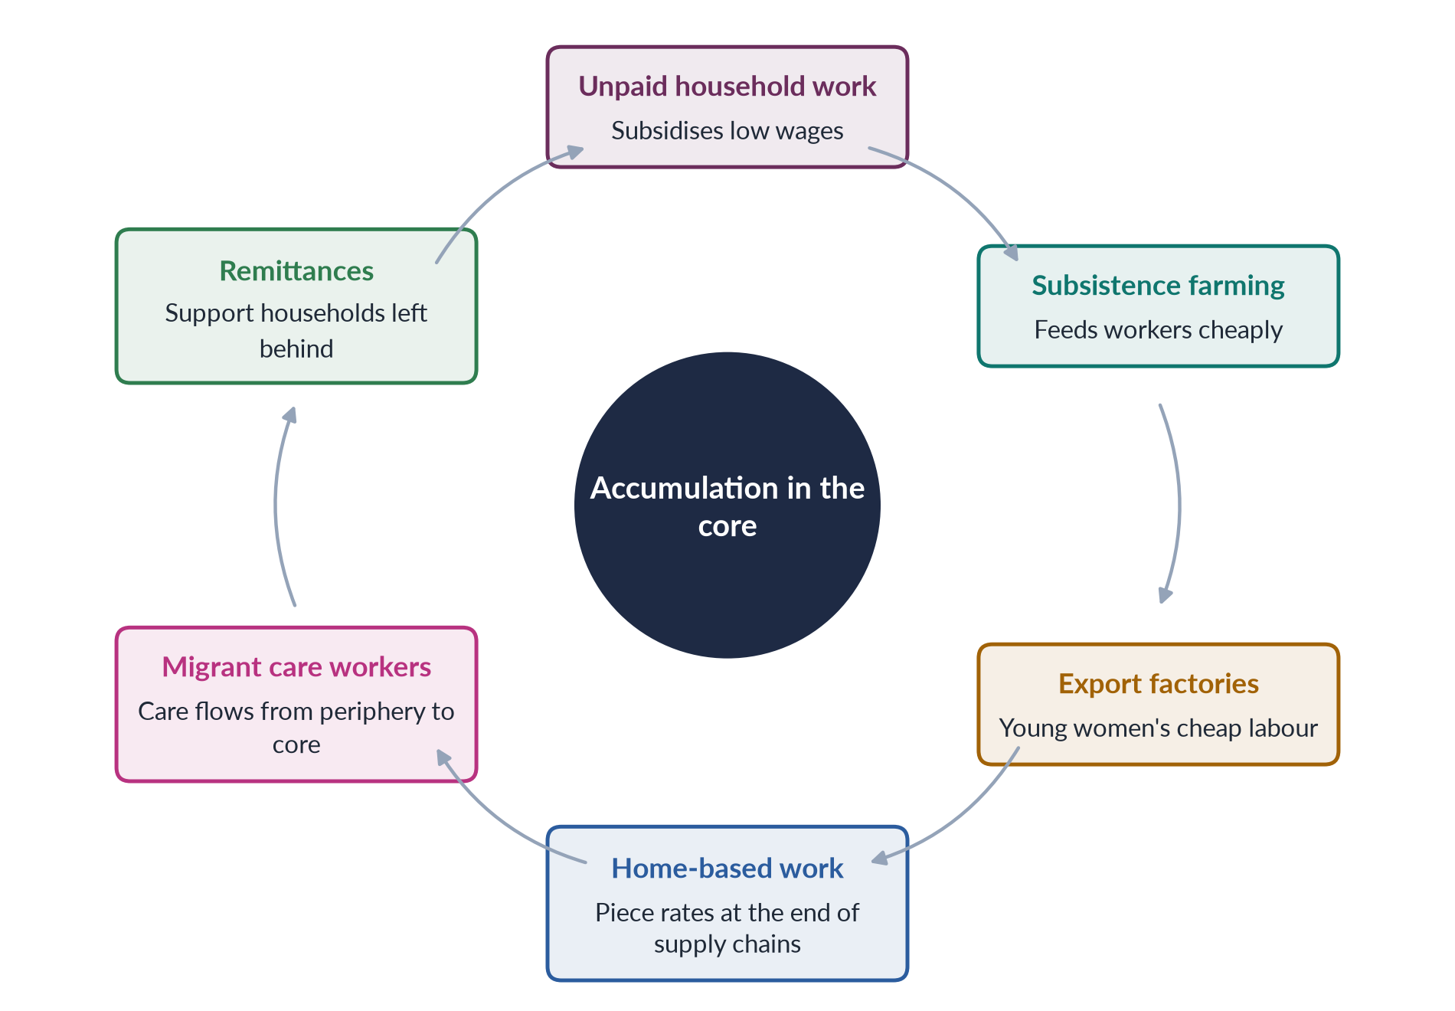
Figure 13 · How the world-system draws on women's labour.

6.4 Critical evaluation
BALANCED VIEW · DOES GLOBALISATION ONLY INCREASE GENDER INEQUALITY?
• Evidence of harm: unsafe factories (the Rana Plaza building collapse in Bangladesh, 24 April 2013, killed more than 1,100 garment workers, most of them women; the Ali Enterprises fire in Karachi, 2012); low wages; insecure contracts; care drain; trafficking.
• Evidence of gains: export jobs gave millions of young women in Bangladesh, Sri Lanka and elsewhere their first independent income, delayed marriage and increased their bargaining power at home. Naila Kabeer (The Power to Choose, 2000) found Bangladeshi garment workers valued their jobs despite poor conditions.
• Limits of the theory: world-system theory can make women look like passive victims of a global machine; it underplays local patriarchy, state policy and women's agency and organising (unions, NGOs, fair-trade campaigns).
➜ The verdict: globalisation is gendered — it creates new opportunities and new forms of patriarchal control at the same time. Its effect depends on labour rights, state policy and women's organisation.

6.5 Pakistan in the world-system
- Pakistan is best placed in the periphery or lower semi-periphery: it exports textiles, cotton and rice, imports machinery and fuel, and depends on external finance.
- Women are concentrated at the bottom of global chains: home-based workers, cotton pickers, and workers in garment and football factories.
- Men's migration to the Gulf sends home remittances — a record of more than 38 billion dollars in 2024–25 — while many women manage households alone.
- The EU's GSP+ trade preferences (from 2014) are conditional on Pakistan implementing 27 international conventions, including CEDAW and core labour standards — a case of global trade used to push gender and labour rights.
EXAMINER'S EYE · THE MODEL STRUCTURE FOR 2025
1. Introduction: define globalisation and "gendered globalisation"; thesis. 2. World-system theory (Wallerstein 1974; core, semi-periphery, periphery). 3. Its gender blind spot. 4. Feminist extensions: households (Smith and Wallerstein), housewifisation (Mies), global assembly line. 5. New forms of patriarchal power (six). 6. Evidence of harm and of gains (Rana Plaza; Kabeer). 7. Pakistan. 8. Critical evaluation and conclusion. Draw the pyramid or cycle.

Chapter 7 · Structural Functionalism and Gender
Structural functionalism was a 2019 short note, and a 2019 MCQ asked what it is related to (the stability of society). It is also part of any "critical gender analysis of development theories" (2024).

7.1 What structural functionalism says
✦ DEFINITION
Structural functionalism · a theory of social order
The view that society is like a living body: a system of interrelated parts (institutions such as the family, education, religion, economy and government), each performing a function that keeps the whole stable and in balance (equilibrium). Social arrangements exist because they are useful to society.
➜ Key words: system, function, structure, stability, consensus, equilibrium, socialisation, roles.

- Émile Durkheim (1858–1917) laid the foundations: society is held together by shared values and a division of labour.
- Talcott Parsons (1902–1979), the leading American sociologist of the 1950s, built the full theory.
- Robert Merton added manifest (intended) and latent (unintended) functions, and dysfunctions.
- George Murdock (Social Structure, 1949) argued that the nuclear family is universal and performs four functions: sexual, reproductive, economic and educational.
IN SIMPLE WORDS
A functionalist looks at any custom and asks: "What does this do for society?" If men and women have different roles, the functionalist answer is: "Because the difference helps society run smoothly."

7.2 Parsons on gender: instrumental and expressive roles
✦ THINKER
Talcott Parsons and Robert Bales · *Family, Socialization and Interaction Process* (1955)
In the modern family, the husband-father plays the instrumental role — earning income and linking the family to the wider world — while the wife-mother plays the expressive role — caring, nurturing and providing emotional support. This division is functional: it avoids competition between spouses and gives children stable models. The family's two key functions are the primary socialisation of children and the stabilisation of adult personalities.

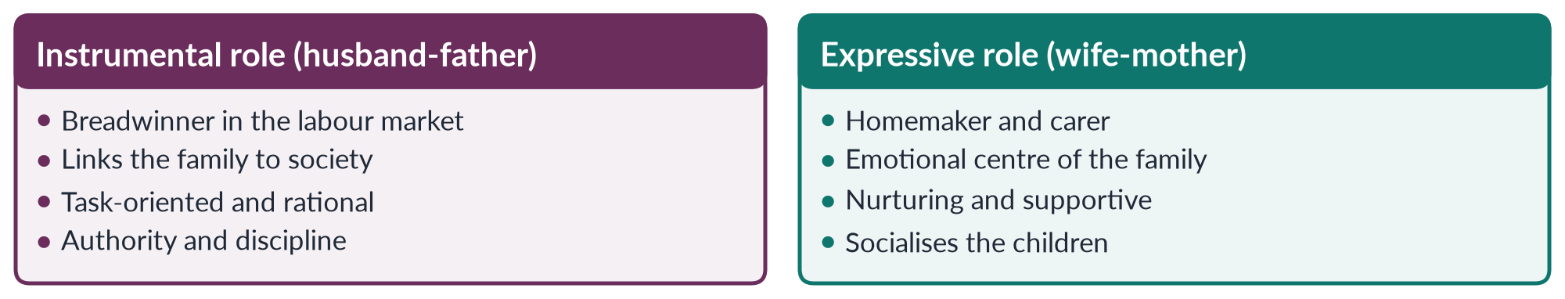
Figure 14 · Parsons's two roles in the family.

7.3 Structural functionalism and development
Functionalism shaped modernisation theory (Chapter 4). Parsons's pattern variables contrasted "traditional" societies (ascribed status, particular loyalties, emotion) with "modern" ones (achieved status, universal rules, rationality). Development was seen as a smooth shift towards the modern pattern — including the Western nuclear family with a male breadwinner. Development planners of the 1950s–60s therefore:
- treated men as producers and household heads;
- treated women as mothers and homemakers (welfare, nutrition and family-planning projects);
- assumed that household income was shared fairly.

7.4 The gender critique of structural functionalism
1. It justifies inequality. By calling the gender division of labour "functional", it presents women's subordination as natural and necessary. Functional for whom? For men and employers, not necessarily for women.
2. It ignores power and conflict. It assumes consensus; it has no place for domestic violence, men's control of money, or conflict of interest between spouses. Conflict theorists and feminists put power at the centre.
3. It is historically narrow. The breadwinner–homemaker family was typical of middle-class, white America in the 1950s — not of most societies, where women have always worked in fields, markets and crafts.
4. It ignores women's economic work. Women's productive work — in farming, home-based production, the informal sector — disappears from view.
5. It resists change. A theory of stability explains poorly how and why gender roles change.
6. Biological assumptions. It treats women's caring role as following from childbirth and nursing, rather than from social construction (Topic 1).
Critics include Betty Friedan (The Feminine Mystique, 1963), who showed how unhappy the "expressive" housewife often was; Ann Oakley (The Sociology of Housework, 1974), who studied housework as real, often monotonous work; and Marxist feminists, who showed that the "functional" family serves capitalism (Chapter 3).

7.4a Functionalism and development planning: an example
In the 1960s and 1970s, agricultural extension services in many countries trained men as farmers and offered women only home-economics classes in cooking and sewing — because, in functionalist terms, the man was the "instrumental" provider and the woman the "expressive" homemaker. In regions where women did much of the farming, this wasted their knowledge and lowered productivity. Pakistan's own extension services long followed this pattern; women livestock keepers and farmers still receive far less advice and credit than men.

7.5 What remains useful
- It reminds us that gender roles are tied to institutions — family, school, religion, economy — and that change in one affects the others.
- Its concept of socialisation explains how children learn gender roles.
- Its concept of dysfunction can be used critically: rigid gender roles are dysfunctional when they waste women's talent, harm health or keep families poor.
PAKISTAN ANGLE · FUNCTIONALIST IDEAS IN PAKISTAN
The idea that men are providers (kafeel) and women homemakers is strong in Pakistani society and appears in textbooks, sermons and dramas. It is often defended as "functional" for family stability. Yet most rural women already do heavy productive work in fields and with livestock, and rising prices push more urban families to need two incomes. Male migration leaves many women running households alone. The functionalist picture no longer fits much of Pakistani reality — which is why its gender critique matters for policy.

EXAMINER'S EYE · SHORT NOTE ON STRUCTURAL FUNCTIONALISM (2019)
Define it (society as a system of functioning parts; stability — the MCQ key). Durkheim, Parsons, Murdock (1949). Parsons and Bales (1955): instrumental and expressive roles. Link to modernisation and development planning. Four or five critiques (justifies inequality; ignores power; 1950s middle-class model; ignores women's work; resists change). One Pakistani example. A small compare figure of the two roles.

Chapter 8 · The Development Theories Compared: A Critical Gender Analysis
"Give a critical gender analysis of development theories" (2024). This chapter brings Chapters 4–7 together and adds the feminist and post-development critiques, so that you can answer a question on the theories as a group.

8.1 What a "critical gender analysis" means
A gender analysis of a theory asks: what does it say about women and men; what does it assume; what does it leave out; and what would its policies do to gender relations? A critical analysis also judges its strengths and weaknesses and asks whose interests it serves.
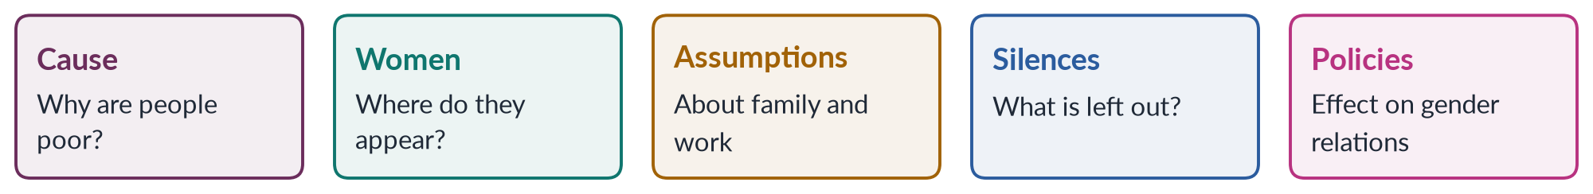
Figure 15 · Five questions for a critical gender analysis of any development theory.

8.2 The master table
Table 4 · The four development theories — a critical gender analysis.
Theory | Cause of poverty | View of women | Main gender critique | Gender-aware use today
Modernisation (Rostow 1960) | Internal "tradition" | Freed by modernity; mothers and homemakers | Blames culture; ignores structures; men captured benefits (Boserup) | Education, urbanisation and media do widen choices
Dependency (Frank 1966) | External exploitation by the centre | Largely absent | Gender-blind; ignores local patriarchy and unpaid work | Explains cheap female labour and debt
World-system (Wallerstein 1974) | A single unequal world economy | Absent at first; later households and the global assembly line | Early gender blindness; women as victims | Gendered globalisation, care chains
Structural functionalism (Parsons 1955) | Incomplete modernisation | Expressive role in the home | Justifies inequality; ignores power and women's work | Institutions and socialisation

8.3 Five shared weaknesses
1. Gender blindness. All four theories began by treating "society", "the economy" or "the nation" as gender-neutral.
2. Invisibility of unpaid work. None counted the unpaid care and subsistence work on which economies rest.
3. The household as a unit. All assumed the household is a harmonious unit that shares income fairly. Feminist economists (Amartya Sen's "cooperative conflict", 1990; Bina Agarwal, 1997) showed households are sites of bargaining in which women often lose.
4. Women as passive. Women appear as victims of tradition (modernisation), of global capital (dependency, world-system) or as keepers of the home (functionalism) — rarely as actors.
5. Male-centred models of progress. Progress was measured by male-dominated sectors — industry, cash crops, formal jobs.

8.4 The feminist responses
The critique of these theories produced the three approaches of the next chapters:
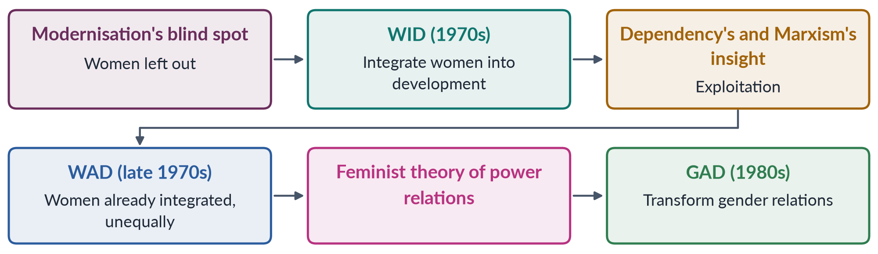
Figure 16 · From development theories to gender approaches.
- WID answered modernisation: "include women" (Chapter 9).
- WAD drew on dependency and Marxist theory: "women are exploited within the system" (Chapter 10).
- GAD drew on socialist feminism: "change gender relations of power" (Chapter 11).

8.5 Later critiques
- Human development and capabilities (Haq, Sen, Martha Nussbaum, Women and Human Development, 2000): judge development by people's real freedoms, including women's.
- Post-development and decolonial critiques (Escobar, 1995; Mohanty, 1984; Lugones, 2007): development itself can reproduce colonial power (Chapter 3).
- Feminist economics (Marilyn Waring, Diane Elson, Nancy Folbre): count and value care.
- Ecofeminism and feminist environmentalism (Chapter 14): development that destroys nature harms women first.
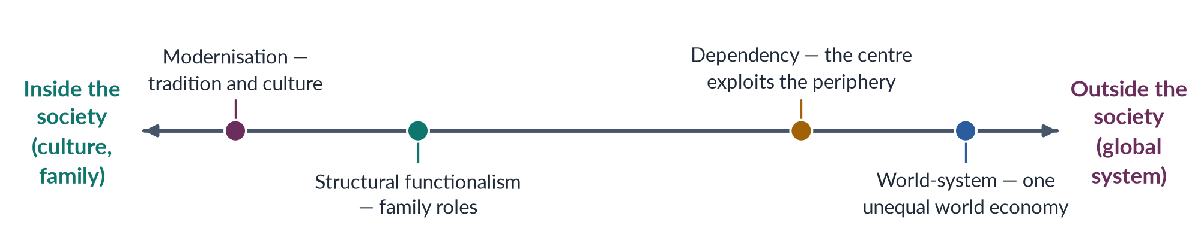
Figure 17 · Where the theories place the cause of women's disadvantage.

8.5a What each theory would recommend for women — and what a gender analysis adds
Table 5 · Policy implications of each theory for women.
Theory | Its recommendation | What a gender analysis adds
Modernisation | Educate women; spread modern values; family planning | Change land, credit and inheritance too; count unpaid work
Dependency | Break unequal ties; national self-reliance | Change local patriarchy; value women's subsistence work
World-system | Rise from periphery to semi-periphery | Protect women workers in export chains; care-chain rights
Structural functionalism | Support stable family roles | Treat roles as changeable; share care between men and women

A gender analysis therefore does not reject these theories; it completes them by asking about women's work, property, time and power in each case.

8.6 A balanced conclusion
Each theory captures part of the truth. Culture matters (modernisation); institutions shape roles (functionalism); global structures exploit poor countries (dependency, world-system). What all lacked was attention to gender relations of power — inside households, markets and states. A critical gender analysis joins the local and the global, the cultural and the structural, and adds unpaid work and women's agency.
PAKISTAN ANGLE · APPLYING THE THEORIES TO ONE PAKISTANI WOMAN
A woman cotton picker in southern Punjab:
• Modernisation would say her poverty comes from tradition and lack of education.
• Functionalism would treat her as a homemaker who "helps" in the fields.
• Dependency would point to low world cotton prices and Pakistan's weak position in trade.
• World-system would place her at the bottom of a global textile chain whose profits flow to the core.
• A gender analysis adds: she does most of the family's unpaid care; she owns no land; her wages are paid to her husband; she has no labour protection — and she may be organising with other women for better rates.

EXAMINER'S EYE · THE MODEL STRUCTURE FOR 2024
1. Introduction: what "critical gender analysis" means; the five questions. 2–5. One heading per theory — claims, view of women, critique. 6. Comparative table. 7. Shared weaknesses. 8. Feminist responses (WID, WAD, GAD) and later critiques. 9. Pakistan (the cotton picker). 10. Conclusion: join the local and global. Draw the spectrum or the table.

Chapter 9 · Women in Development (WID)
WID, WAD and GAD are the single most-asked family in Topic 4: "critically review" all three (2016), "critically analyse" all three (2021), "critically analyse WID and GAD … principles and limitations" (2025), and a short note on "gender and development" (2017). MCQs ask where WID was coined (Washington), which approach takes the sexual division of labour for granted (WID), and what WID was criticised for.

9.1 Origins
Until about 1970, development planners assumed that women would benefit automatically from growth, and treated them mainly as mothers — through welfare, nutrition and family-planning programmes. This is often called the welfare approach.
✦ THINKER
Ester Boserup · *Woman's Role in Economic Development* (1970)
The Danish economist showed that women were major producers, especially in African agriculture, and that colonial and modernising policies had marginalised them by giving land, technology, training and credit to men. Development was leaving women behind — and sometimes making them worse off.
➜ Boserup's book is the starting point of WID.

- The term "Women in Development" was coined in the early 1970s by a network of women development professionals in Washington, DC (the Women's Committee of the Washington chapter of the Society for International Development) — the key to a 2018 MCQ.
- The Percy Amendment (1973) to the US Foreign Assistance Act required US aid to integrate women into the national economies of developing countries. USAID created an Office of Women in Development (1974).
- The UN's International Women's Year (1975), the Mexico City conference and the Decade for Women (1976–85) spread WID worldwide; many governments created women's ministries or divisions (Pakistan's Women's Division, 1979).

9.2 Principles of WID
✦ DEFINITION
WID · Women in Development
An approach (1970s) which held that women had been left out of development, and that the solution was to integrate women into existing development — through education, training, credit, technology and income-generating projects — so that they could contribute to and benefit from growth.
➜ Key words: integration, access, efficiency, women-only projects, equal opportunity.

1. Women are an untapped resource for development.
2. The problem is exclusion, not the development model itself.
3. The solution is access: education, credit, training, technology and jobs.
4. Liberal feminism is its theory: equal opportunity within the existing system.
5. Separate women's projects and women's units in ministries.
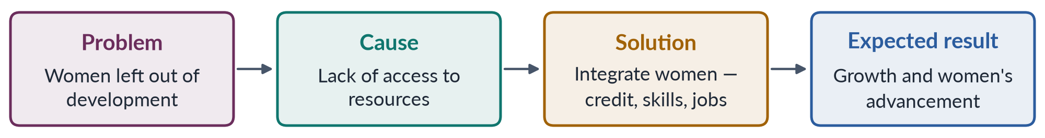
Figure 18 · The WID logic.

9.3 WID's policy approaches
Caroline Moser (1993) grouped the policy approaches of this era:
- Equity (the original WID approach): equal rights and status for women, including through legal reform. Governments found it threatening, and it faded.
- Anti-poverty: raising poor women's incomes through small income-generating projects.
- Efficiency (from the 1980s): involving women because it makes development more efficient — often meaning using women's unpaid time to deliver services during structural adjustment.

9.3a WID in practice: typical projects
- Income-generating projects — sewing, knitting, handicrafts, poultry and kitchen gardens for women's groups.
- Credit schemes — small loans to women, later expanded as microfinance.
- Training — literacy, vocational skills, home economics.
- Appropriate technology — improved cooking stoves, grain mills and water pumps to save women's time.
- Women's units in ministries and aid agencies to review projects for their effect on women.
Many such projects were designed by outsiders, run separately from the main (male-dominated) development programmes, and given small budgets. Critics called this the "women's ghetto" of development.

9.4 Achievements of WID
1. It made women visible in development statistics, research and planning.
2. It created institutions: women's ministries, WID units in aid agencies, UN bodies such as the Voluntary Fund for the Decade for Women (1976, later UNIFEM) and INSTRAW.
3. It won resources for women: education, health, credit and training.
4. It showed that women are producers, not only mothers.
5. It prepared the ground for CEDAW (1979).

9.5 Limitations and critique of WID
1. It accepted the existing model of development. It asked women to join a process without asking whether that process was fair — "add women and stir".
2. It took the sexual division of labour for granted (MCQ 2024). It added paid work to women's burden without changing who does unpaid care — increasing their workload.
3. It focused on women alone, not gender relations. It did not examine men's power in households, markets and states.
4. It ignored class, race and global inequality. Its liberal model suited educated women better than poor ones; it ignored the international system (the WAD critique).
5. Small, marginal projects. Income-generating projects — sewing, handicrafts, poultry — were often tiny, under-funded and trapped women in low-return "feminine" activities.
6. Western bias. It assumed the Western model of women's advancement fitted all societies.
7. Instrumentalism. It often justified investing in women because it made development efficient, not because women have rights.
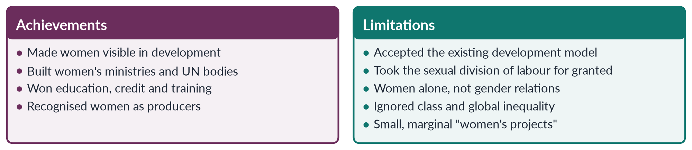
Figure 19 · WID: achievements and limitations.
A 2026 MCQ asked what WID was primarily criticised for. The key: its failure to transform gender relations — it integrated women into development without changing the structures and power relations that subordinate them.
PAKISTAN ANGLE · WID IN PAKISTAN
Pakistan's Women's Division (1979) and later Ministry of Women Development followed the WID model: separate women's projects, vocational centres, sewing and handicraft training, and small credit schemes. The First Women Bank (1989) was a WID-style institution. These efforts gave some women skills and income, but the scale was small and most did not change women's position in land, inheritance, wages or decision-making — the limits WID's critics predicted.

Chapter 10 · Women and Development (WAD)
WAD is the middle approach — a critique of WID from the left. It is asked in every WID/WAD/GAD question (2016, 2021), and the 2026 question on NGO-isation told candidates to "use the WAD critique" (Topic 3, Chapter 10).

10.1 Origins
In the second half of the 1970s, scholars influenced by Marxism and dependency theory criticised WID. A landmark was the workshop "The Continuing Subordination of Women in the Development Process" at the Institute of Development Studies (IDS), Sussex, in 1978, which brought together feminist researchers from North and South. Scholars from the global South, disappointed that WID projects did little for poor women, shaped the approach.

10.2 Principles of WAD
✦ DEFINITION
WAD · Women and Development
An approach (late 1970s) which argued that women have always been part of development — as producers, workers and carers — but that they were integrated on unequal and exploitative terms. The problem is not women's exclusion but the nature of development itself: an unequal international and class system that exploits both poor men and poor women.
➜ Key words: integration on unequal terms, exploitation, class, dependency, international inequality, structural change.

1. Women are already "in" development. Their labour sustains households, farms and export industries.
2. Development is unequal. Global capitalism, the international division of labour and class structures exploit the poor; women's position improves only if these structures change.
3. Women's work is undervalued. Both paid and unpaid work are exploited.
4. Theory: Marxist and dependency theory, and socialist feminism.
5. Strategy: women-only projects and organisations to protect women's interests, together with structural change in national and international economies.
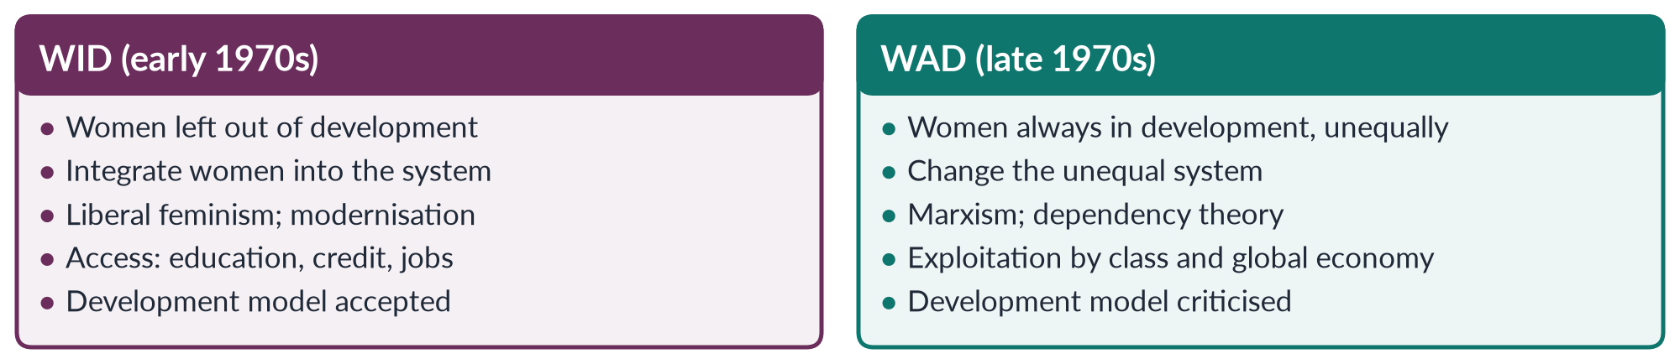
Figure 20 · WID and WAD.

10.3 Contributions of WAD
1. It asked "development for whom?" — shifting attention from women's absence to the structures that exploit them.
2. It linked women's position to class and global inequality — North–South relations, debt, trade.
3. It valued women's knowledge and existing work.
4. It gave the South a voice — critiques from Southern scholars and activists.
5. It prepared the way for GAD and for DAWN's critique of development (1984–85).

10.4 Limitations and critique of WAD
1. Class over gender. It focused on class and international inequality, and said little about gender relations within classes — why poor men also dominate poor women.
2. Ignored patriarchy. Like dependency theory, it assumed that women's position would improve when international structures became fair, underplaying local patriarchy.
3. Women as a homogeneous group. It treated poor women's interests as one, overlooking differences of race, ethnicity and caste.
4. Little on the household. It paid little attention to the reproductive and household work within families.
5. Women-only projects again. In practice it often supported separate women's projects, repeating WID's marginalisation.
6. Weak policy influence. Its call for structural change was hard for governments and donors to adopt.

10.4a WAD in action: three examples
1. Export processing zones. WID would count women's factory jobs as "integration" and success. WAD asks why the zones exist — to supply cheap labour to multinational companies — and notes that women are hired precisely because they can be paid less. Integration here is exploitation.
2. Cash crops. When a government promotes cotton or tobacco for export, WID asks whether women get training. WAD asks who profits from the crop, why world prices keep rural wages low, and how the shift from food crops affects household food security, which women manage.
3. Aid projects. WAD warns that small women's projects funded by foreign donors can leave the international economic order — debt, unequal trade — untouched, while giving the appearance of progress.
IN SIMPLE WORDS
WID says: "Let women in." WAD replies: "Women are already in — at the bottom. The question is who owns the building."

10.4b WAD, dependency and the New International Economic Order
WAD appeared at the same time as the Southern demand at the UN for a New International Economic Order (1974) — fairer commodity prices, debt relief and technology transfer. WAD thinkers argued that women in the South would gain most from a fairer world economy, and that Southern women and men shared an interest in changing it. This shared North–South framing was later criticised by GAD for hiding conflicts of interest between women and men in the South.

10.5 The WAD critique today
The WAD lens is still used to judge programmes that add women to markets or projects without changing the economic structures that exploit them — micro-credit schemes, handicraft projects, export-factory jobs, and donor-driven NGO projects (Topic 3, Chapter 10).
PAKISTAN ANGLE · WAD IN PAKISTAN
A home-based embroiderer in Hyderabad trained by a donor project still sells through a middleman at piece rates set by exporters, owns no land, and does all the housework. Her small income may rise, but her position does not change. The WAD lens asks who owns the land, who sets the price, who controls the export chain and who does the unpaid care — and why a three-year project cannot answer any of these questions. Peasant women's struggles in the Okara military farms (from 2000) and the Sindhiani Tehreek (from 1982), which joined class and land struggles, are closer to WAD's idea of change.

Chapter 11 · Gender and Development (GAD): Needs, Roles, Empowerment and Mainstreaming
GAD is the approach most development agencies now claim to follow. This chapter covers its principles and limits (2016, 2021, 2025), practical and strategic gender needs (a 2018 short note and a 2026 MCQ), Moser's triple role, Kabeer's empowerment, gender mainstreaming (MCQs 2024, 2025) and a master comparison of WID, WAD and GAD.

11.1 Origins
GAD emerged in the 1980s from socialist-feminist scholars — many linked to the IDS "Subordination of Women" group, such as Kate Young — and from Southern networks. The network DAWN (Development Alternatives with Women for a New Era), founded in Bangalore in 1984, presented Development, Crises and Alternative Visions (Gita Sen and Caren Grown) at the Nairobi conference (1985), calling for development driven by poor women's needs and empowerment. The Beijing Platform (1995) adopted GAD's language of gender mainstreaming and empowerment.

11.2 Principles of GAD
✦ DEFINITION
GAD · Gender and Development
An approach (1980s onwards) that focuses not on "women" alone but on gender relations — the socially constructed relations of power between women and men — in households, markets, communities and states. It seeks to transform these relations so that women and men share resources, work and power equally.
➜ Key words: gender relations, power, social construction, empowerment, strategic interests, transformation, mainstreaming.

1. Gender, not women. Look at women and men, and the relations between them.
2. Gender is socially constructed — so it can change (Topic 1).
3. Both production and reproduction. Value unpaid care and household work, and look inside the household.
4. Women as agents, not passive recipients — empowerment through collective organisation.
5. Transformation. Challenge unequal structures — laws, property, institutions — not only give access.
6. The state's role. The state should promote women's emancipation and provide social services.
7. Intersection of gender with class, race and other identities.
A 2025 MCQ asked what GAD focuses on — the answer was "all of these" (gender relations, power, social roles).

11.3 Practical gender needs and strategic gender interests
✦ THINKER
Maxine Molyneux · "Mobilization without Emancipation?" (1985)
Studying women in Nicaragua, Molyneux distinguished practical gender interests (arising from women's position within the existing gender division of labour) from strategic gender interests (arising from analysis of women's subordination and aimed at ending it).
➜ Caroline Moser (1989, 1993) turned these into the planning tools practical gender needs and strategic gender needs.

Table 6 · Practical gender needs and strategic gender interests.
Point | Practical gender needs (PGNs) | Strategic gender interests / needs (SGNs)
Meaning | Immediate, material needs arising from women's current roles | Long-term interests in changing women's subordinate position
Examples | Water supply, health care, food, housing, fuel, income, childcare | Land and inheritance rights, laws against violence, equal wages, political power, control over one's body
Relation to gender roles | Accept the existing division of labour | Challenge the division of labour and power
Time frame | Short term | Long term
Who benefits | Women and their families, within current roles | Women as a group, by changing their position
Typical approach | Welfare, anti-poverty, efficiency | Equity, empowerment
Example in Pakistan | A hand pump near home saves hours of walking | Women's ownership of land under the 2020 property-rights law

A 2026 MCQ: practical gender needs differ from strategic interests because they address immediate necessities.
IN SIMPLE WORDS
A practical need makes a woman's present life easier: a well near her house. A strategic interest changes her position: a law and a local committee that give her a say over who controls the well — and the land around it.

The two are linked: meeting practical needs through women's organisations can open the way to strategic change — for example, a women's water committee that later demands seats on the village council.

11.4 Moser's triple role and five policy approaches
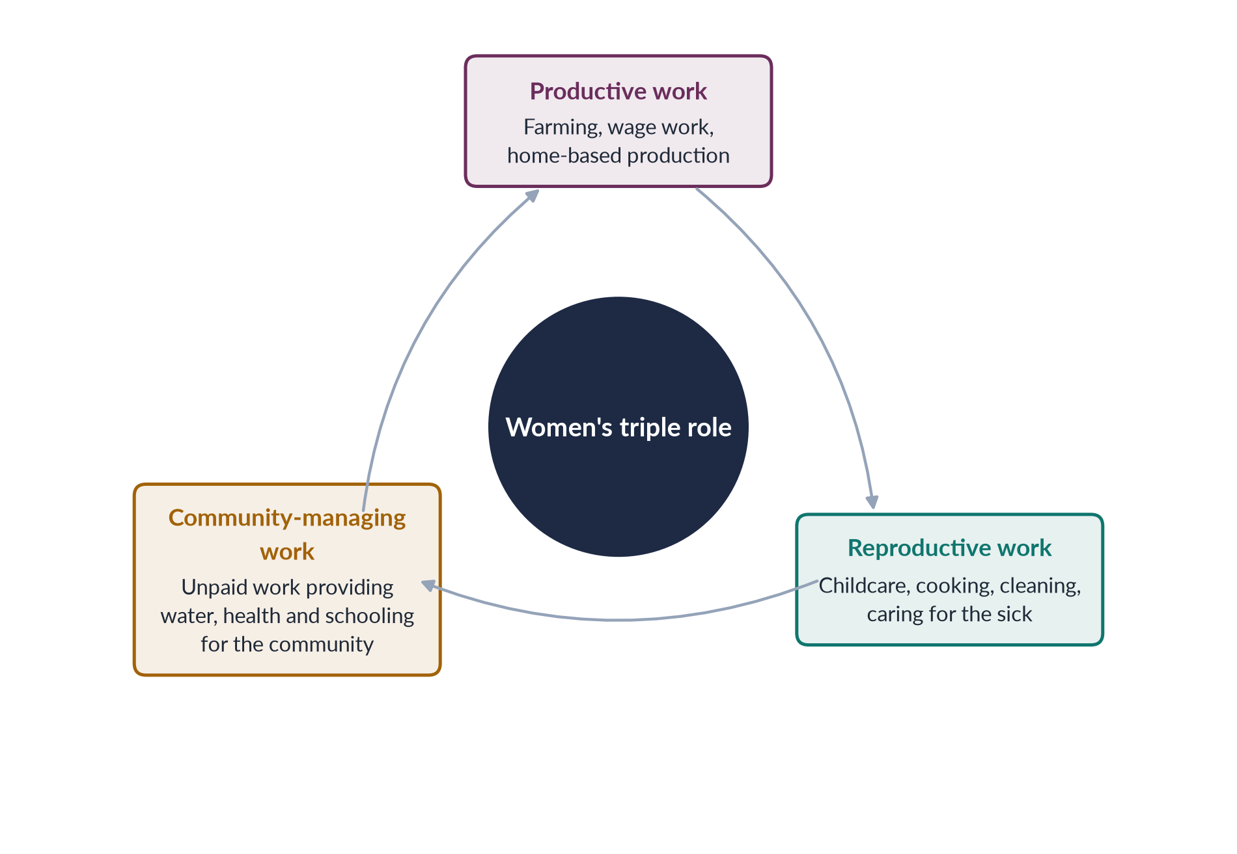
Figure 21 · Moser's triple role of women.
Caroline Moser (Gender Planning and Development, 1993) showed that women carry a triple role, while men usually have productive and community-politics roles (paid, with status). Planners who ignore the triple role overload women.
Table 7 · Moser's five policy approaches to women in the South.
Approach | Period | Aim and view of women
Welfare | 1950s– | Women as mothers; food aid, nutrition, family planning; meets practical needs
Equity | 1970s | The original WID approach: equality through law and access; strategic but seen as threatening
Anti-poverty | 1970s– | Poor women's income; small income-generating projects; practical needs
Efficiency | 1980s– | Women's participation makes development efficient; often relies on women's unpaid time during adjustment
Empowerment | 1980s– | Women's self-reliance through bottom-up organisation; strategic interests (from DAWN and the South)

11.5 Empowerment
✦ THINKER
Naila Kabeer · *Reversed Realities* (1994); "Resources, Agency, Achievements" (1999)
Kabeer defined empowerment as "the expansion in people's ability to make strategic life choices in a context where this ability was previously denied to them". It has three linked dimensions: resources (material, human and social), agency (the ability to define goals and act on them) and achievements (outcomes).
➜ A 2018 MCQ asked the author of Reversed Realities: Naila Kabeer.

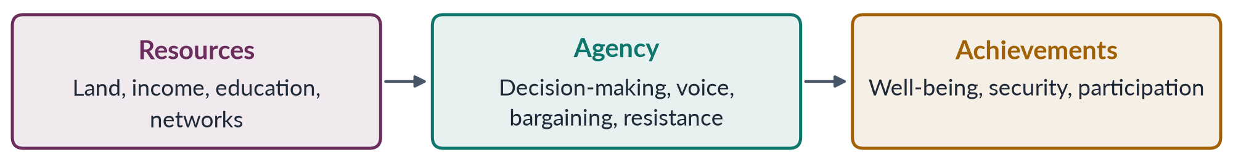
Figure 22 · Kabeer's three dimensions of empowerment.
- A 2023 MCQ: transforming grassroots women from mere beneficiaries to active participants is empowerment.
- Sara Longwe's Women's Empowerment Framework sets out five levels: welfare, access, conscientisation, participation, control.
- The Harvard Analytical Framework (1985) maps who does which activities and who has access to and control over resources.

11.6 Gender mainstreaming
✦ DEFINITION
Gender mainstreaming · the Beijing strategy
"The process of assessing the implications for women and men of any planned action, including legislation, policies or programmes, in all areas and at all levels" (UN ECOSOC, 1997), so that inequality is not perpetuated.
➜ A 2024 MCQ: the first global policy framework to adopt gender mainstreaming was the Beijing Declaration (1995). A 2025 MCQ: its benefits are "all of these".

Tools of mainstreaming: sex-disaggregated data, gender analysis of policies, gender-responsive budgeting, gender audits, gender focal points in ministries, and quotas.
PAKISTAN ANGLE · GAD TOOLS IN PAKISTAN
• Gender Reform Action Plans (2000s) aimed to raise women's share of government jobs and create gender units.
• Gender-responsive budgeting pilots in federal and provincial budgets.
• The 10% quota for women in federal government jobs and provincial quotas.
• BISP (2008) pays cash to women, giving them a resource in their own name — and some studies suggest greater say in household decisions.
• Strategic laws: the Enforcement of Women's Property Rights Act 2020, laws against violence and child marriage.

11.7 Limitations of GAD
1. Hard to implement. Transforming power relations is political; agencies often reduce GAD to checklists and training.
2. "Gender" can hide women. Talking about "gender" lets agencies shift money away from women-specific programmes.
3. Mainstreaming can mean "mainstreamed away". When everyone is responsible, no one is.
4. Depoliticisation. Donor-driven, technocratic gender work (Topic 3, NGO-isation).
5. Resistance. Men and elites resist changes in power; governments avoid controversial strategic issues.
6. Western concepts? Some critics say "empowerment" and "gender" are imposed from outside; others reply that they came from Southern networks such as DAWN.

11.8 WID, WAD and GAD compared
Table 8 · The three approaches compared.
Point | WID (1970s) | WAD (late 1970s) | GAD (1980s–)
Focus | Women | Women and class | Gender relations of power
Problem | Women excluded from development | Women integrated on unequal terms | Unequal power between women and men
Theory | Liberal feminism; modernisation | Marxism; dependency | Socialist feminism
Goal | Integrate women; efficiency | Change the international and class system | Transform gender relations; empowerment
Strategy | Women's projects, credit, training | Women's projects; structural change | Mainstreaming, empowerment, strategic needs
Household | Unit; not examined | Little attention | Inside the household — bargaining
Needs met | Practical | Practical | Practical and strategic
View of women | Passive recipients | Workers exploited | Agents of change
Main critique | Accepts status quo; "add women and stir" | Ignores patriarchy within classes | Hard to implement; can hide women
Key names | Boserup (1970); Percy Amendment (1973) | IDS (1978) | Molyneux (1985), Moser (1993), Kabeer (1994), DAWN (1984)

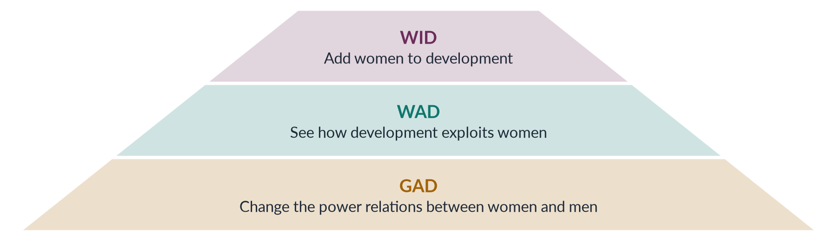
Figure 23 · From WID to GAD: how the approaches deepened.
EXAMINER'S EYE · THE MODEL STRUCTURE FOR 2025 (WID AND GAD)
1. Introduction: from welfare to WID to GAD. 2. WID — origins (Boserup, Percy, Washington), principles, achievements. 3. WID limitations. 4. GAD — origins (IDS, DAWN, Beijing), principles. 5. GAD tools: PGNs/SGNs, triple role, empowerment, mainstreaming. 6. GAD limitations. 7. Comparison table. 8. Pakistan: Women's Division and vocational centres (WID); BISP, property law, mainstreaming (GAD). 9. Conclusion: meet practical needs in ways that open strategic change.

Chapter 12 · The Gender Critique of Structural Adjustment Policies
"Discuss in detail the gender critique of Structural Adjustment Policies (SAPs)" (2022). The same ideas explain the effects of IMF programmes on Pakistani women today, a likely future question.

12.1 What SAPs were
In the late 1970s and 1980s many developing countries fell into a debt crisis (it broke out when Mexico could not pay in 1982). To get new loans from the IMF and World Bank, governments had to accept conditions — a package later called the "Washington Consensus" (a term coined by the economist John Williamson in 1989).
✦ DEFINITION
Structural Adjustment Programmes (SAPs) · 1980s–1990s
Packages of economic reforms required by the IMF and World Bank in return for loans, aimed at reducing deficits, controlling inflation and opening economies to markets.

Table 9 · The main SAP conditions.
Condition | What it means
Cut government spending | Reduce budgets for health, education, food subsidies and public jobs
Remove subsidies | End subsidies on food, fuel and electricity, so prices rise
User fees | Charge people for public health care and schooling
Devalue the currency | Make exports cheaper and imports (including food and medicine) dearer
Privatise | Sell state enterprises; cut public-sector jobs
Liberalise trade and finance | Remove tariffs and controls; promote exports
Deregulate labour markets | Weaken labour protections to make labour "flexible"

12.2 Why SAPs were called "gender-blind"
SAPs were designed as if the economy had only markets and the state. They ignored the third part of the economy — the household, where unpaid care work keeps people alive. When the state cut services and prices rose, households had to fill the gap — and inside households the extra work fell on women.
✦ THINKER
Diane Elson · *Male Bias in the Development Process* (1991)
Elson argued that adjustment policies contain male bias: they assume that women's unpaid work can expand without limit to absorb the costs of cuts — treating women's labour as if it were "infinitely elastic". Resources were meant to shift from "non-tradeable" to "tradeable" goods, but no one counted the shift of work from the paid economy to women's unpaid labour.
➜ Elson's argument is the centre of the gender critique.

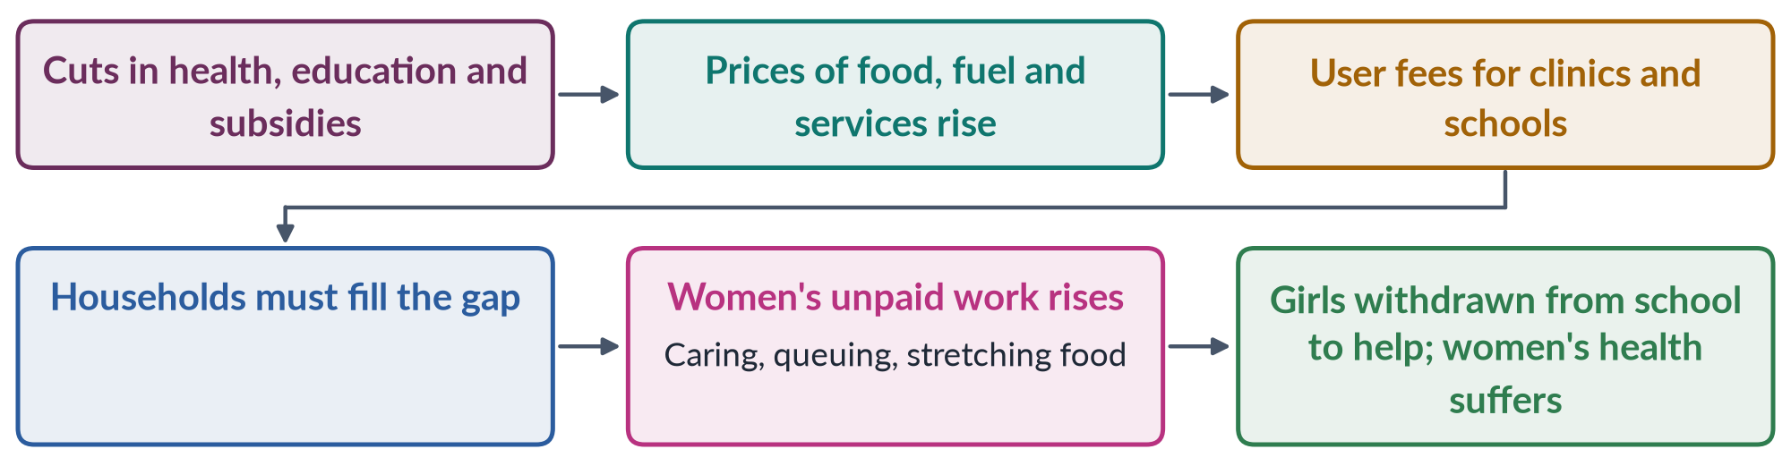
Figure 24 · How structural adjustment shifted costs onto women.

12.3 The gender critique, point by point
1. Increased unpaid work. When hospitals charged fees or discharged patients early, women cared for the sick at home. When subsidies ended, women spent more time stretching food and fuel.
2. Women's health. Cuts to health spending and user fees reduced women's use of maternal health services; maternal deaths rose in some countries.
3. Girls' education. School fees and household poverty led families to withdraw girls first, to save money and help at home.
4. Loss of jobs. Public-sector cuts removed jobs in teaching, nursing and administration where women were concentrated.
5. Informal and insecure work. Women were pushed into informal work — petty trade, home-based production — to make up lost income, often for very low returns.
6. Export-led growth. New export jobs (garments, electronics, flowers) went to women but were low-paid, insecure and without labour rights.
7. Food prices. Removal of food subsidies hit poor women, who are responsible for feeding families.
8. Violence and stress. Economic stress was linked with rising domestic tension and violence.
9. Men lost the breadwinner role in some places, shifting burdens onto women.
10. No voice. SAPs were negotiated by finance ministries and lenders with no participation by women.

12.4 The evidence and the response
- UNICEF's Adjustment with a Human Face (Cornia, Jolly and Stewart, 1987) documented the harm to children and women and called for protection of the poor during adjustment.
- The Commonwealth Secretariat's Engendering Adjustment for the 1990s (1989) showed the burden on women.
- DAWN (1985) placed the debt crisis at the centre of its critique.
- The IMF and World Bank responded with social safety nets, Poverty Reduction Strategy Papers (1999) and later "gender-responsive" language; critics say the core conditions changed little.
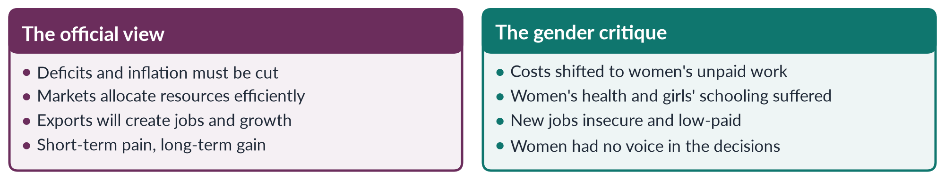
Figure 25 · The official view of SAPs and the gender critique.

12.5 Structural adjustment in Pakistan
- Pakistan's first IMF structural adjustment programme began in 1988; there have been many since. The most recent include a Stand-By Arrangement (2023) and a 7-billion-dollar Extended Fund Facility approved in 2024.
- Typical conditions: raising electricity and gas prices, widening the sales tax, cutting development spending, and reducing subsidies.
- Gendered effects: higher prices for food and energy (managed mainly by women); pressure on health and education budgets; fewer public jobs; rising informal work.
- Protection: the Benazir Income Support Programme, which pays women, has been expanded during IMF programmes as a social safety net — a partial answer to the gender critique, though cash transfers do not replace public services.
BALANCED VIEW · ARE IMF PROGRAMMES ANTI-WOMEN?
• Critics: austerity shifts costs onto women's unpaid work; indirect taxes such as sales tax fall hardest on poor households; cuts hit health and education.
• Defenders: without stabilisation, inflation and default hurt the poor — and women — even more; recent programmes protect BISP spending.
➜ The line to take: stabilisation may be necessary, but it must be gender-assessed — protect health, education and social protection, use progressive taxes, and count unpaid care.

EXAMINER'S EYE · THE MODEL STRUCTURE FOR 2022
1. Introduction: debt crisis; SAPs defined; the gender critique in one line (Elson). 2. SAP conditions (table). 3. Why SAPs were gender-blind (the three-part economy). 4. The critique point by point — unpaid work, health, girls' schooling, jobs, informality, exports, food, violence, voice. 5. Evidence (UNICEF 1987; Commonwealth 1989; DAWN). 6. Official responses and their limits. 7. Pakistan (1988 onwards; 2024 EFF; BISP). 8. Conclusion: adjustment with a gender face. Draw the flow figure.

Chapter 13 · Globalisation and Gender
Globalisation is the most-asked single theme after WID/GAD: "Powerful forces of globalization have highlighted various gender issues … Discuss by quoting examples from developing countries" (2017); "What are the impacts of the global political economy on Pakistani women?" (2018); "Discuss the gendered inequalities created and promoted by globalization" (2019); and "gendered globalisation" with world-system theory (2025 — Chapter 6).

13.1 What globalisation is
✦ DEFINITION
Globalisation · the MCQ definition
The growing interdependence of societies across the world (MCQ 2023) — through trade, investment, finance, technology, migration, media and ideas. The sociologist Anthony Giddens defined it as "the intensification of worldwide social relations which link distant localities".

Its main dimensions:
1. Economic — free trade, multinational companies, global supply chains, financial flows.
2. Political — international institutions (WTO, IMF, UN) and global norms (CEDAW, SDGs).
3. Technological — the internet, mobile phones, social media.
4. Cultural — global media, consumer culture, the spread of ideas and values.
5. Human — migration of workers, students and refugees.
Globalisation accelerated from the 1980s, with structural adjustment, the end of the Cold War (1991), the founding of the World Trade Organization (1995) and the internet.

13.2 How globalisation has highlighted gender issues (2017)
The 2017 statement is true: globalisation has made gender issues visible across cultures.
- Global norms and conferences — Beijing (1995), CEDAW, SDG 5 — put women's rights on every government's agenda.
- Global media and the internet expose violence against women and connect activists (#MeToo, 2017).
- Global supply chains reveal the conditions of women workers — for example after Rana Plaza (Bangladesh, 2013).
- Migration makes women's care work visible across borders.

13.3 Opportunities globalisation has brought women
1. Jobs and income. Export industries hired millions of women: garments in Bangladesh (where women form a large share of the workforce), electronics in East Asia, call centres in India. For many it was their first independent income, which delayed marriage and raised their bargaining power (Naila Kabeer, The Power to Choose, 2000).
2. Information and networks. Mobile phones and the internet give access to markets, banking, education and support.
3. Global rights norms. CEDAW, the SDGs and trade conditions (such as the EU's GSP+) push governments to reform laws.
4. Microfinance and remittances. Small loans (Grameen Bank, founded 1983) and migrants' remittances support household incomes.
5. Changing ideas. Exposure to global media widens images of what women can do.

13.4 Gendered inequalities created or deepened by globalisation (2019)
1. Feminisation of labour — women hired for cheap, flexible, insecure jobs (Guy Standing, 1989).
2. Export processing zones — weak labour rights; bans on unions; long hours; harassment.
3. Informalisation — subcontracting to home-based workers at the end of supply chains, without contracts or social security.
4. Wage gaps — women concentrated in the lowest-paid segments of global chains.
5. Global care chains — women from the Philippines, Indonesia, Sri Lanka and elsewhere migrate to care for richer families, leaving their own children behind (Arlie Hochschild, 2000); abuse of migrant domestic workers under sponsorship ("kafala") systems.
6. Trafficking and the global sex industry.
7. Agricultural displacement — imports and agribusiness undermine small farms where women work.
8. Unsafe workplaces — Rana Plaza (2013, over 1,100 dead) and Ali Enterprises (Karachi, 2012, about 260 dead).
9. Cultural backlash and commodification — consumer culture sells beauty standards (skin-lightening creams) while some groups react to change by tightening control over women.
10. Inequality between countries — gains concentrated in the core; women in poorer countries bear most costs.
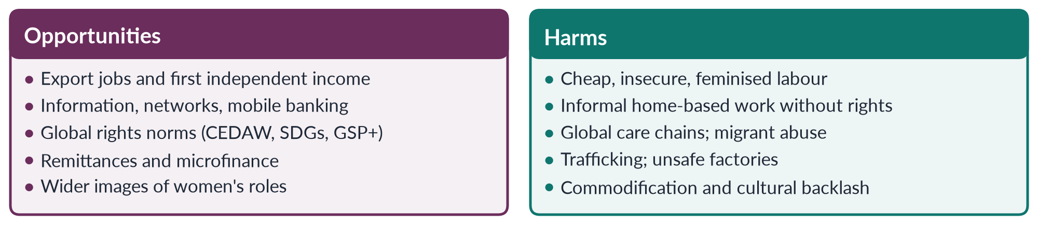
Figure 26 · Globalisation's opportunities and harms for women.

13.5 Globalisation and Pakistani women (2018)
Table 10 · The global political economy and Pakistani women.
Channel | Effect on Pakistani women
Textile and garment exports | The largest export sector; women work in garment units and as home-based stitchers and embroiderers, often on piece rates
Sialkot's sports goods | After the Atlanta Agreement (1997) on child labour, football stitching moved from homes to stitching centres; many women homeworkers who could not travel lost work — a gendered side effect of a global campaign
Agriculture | Cotton-picking women earn little for hard seasonal work linked to world cotton prices
Male migration and remittances | Millions of men work in the Gulf; remittances reached a record of more than 38 billion dollars in 2024–25; many women run households alone, gaining some autonomy but also extra work
IMF programmes and debt | Price rises, sales tax and spending pressure increase women's unpaid work (Chapter 12)
Trade preferences | The EU's GSP+ (from 2014) requires Pakistan to implement 27 conventions including CEDAW and labour standards
Digital economy | Freelancing and online businesses offer some women home-based income, but the mobile-internet gender gap remains 25%
Media and culture | Global media widen images of women's roles and also provoke conservative backlash

✦ DATA
Women in Pakistan's labour force · Labour Force Survey 2024–25
Female labour-force participation was 24.4%. Most employed women work in agriculture or the informal sector. Pakistan ranked 144th of 145 on economic participation in the Global Gender Gap Report 2026.
➜ Globalisation has drawn far fewer Pakistani women into export jobs than in Bangladesh — because of mobility restrictions, transport, safety, and the structure of industry.

13.6 Balanced assessment
BALANCED VIEW · IS GLOBALISATION GOOD OR BAD FOR WOMEN?
Both. It has given many women jobs, information and rights language, and it has also created new forms of exploitation and deepened inequality between and within countries. The difference lies in policy and power: labour rights, social protection, safe transport and childcare, women's unions and associations, and fair terms of trade decide whether women gain or lose.

EXAMINER'S EYE · ANSWERING 2017, 2018 AND 2019
• 2017 ("highlighted gender issues … examples from developing countries"): define; show how globalisation made issues visible; opportunities and harms with country examples (Bangladesh, Philippines, Mexico's maquiladoras, India, Pakistan); conclude.
• 2018 ("global political economy on Pakistani women"): define global political economy; then channel by channel for Pakistan (table above); balance; policy.
• 2019 ("gendered inequalities"): define; ten inequalities with evidence; the other side briefly; conclude with policy.

Chapter 14 · Gender, Environment and Climate Change
"Climate change has gendered impacts. Drawing on feminist environmentalism and ecofeminist perspectives, critically analyse how recent floods and heat waves in Pakistan have affected women differently" (2026). This chapter gives you the theory, the global framework and the Pakistani evidence.

14.1 Why climate change is a gender issue
Climate change does not affect everyone equally. People who depend on natural resources, who have fewer assets, less mobility and less voice suffer most — and in most societies these are disproportionately women. Gender shapes who is exposed to disasters, who can escape, who recovers, and who decides.
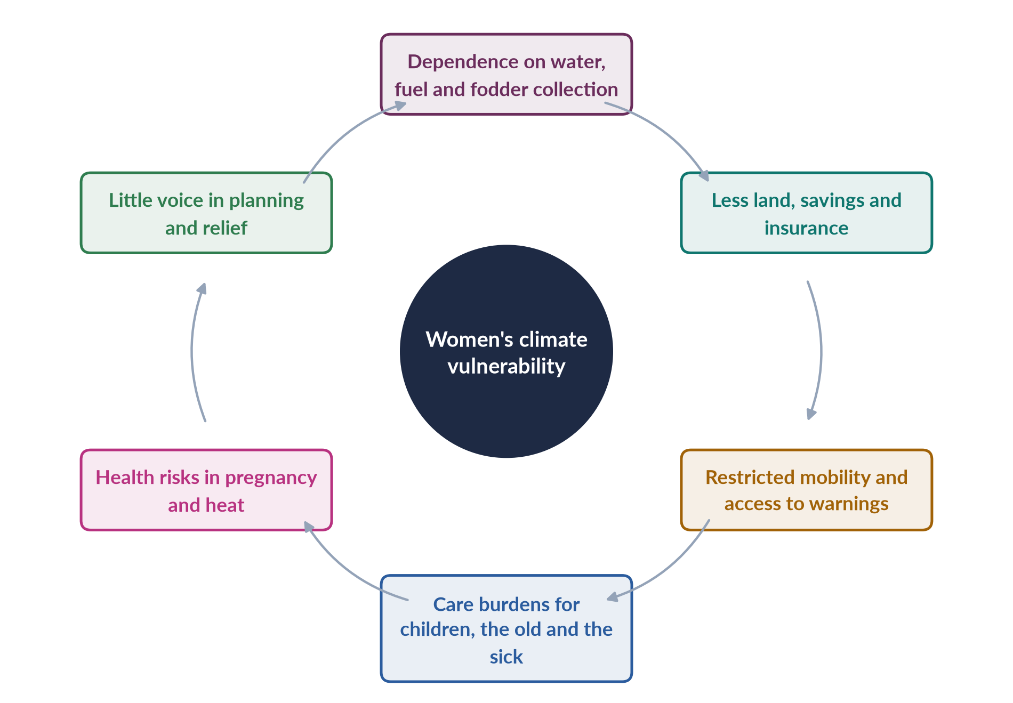
Figure 27 · How gender shapes climate vulnerability.

14.2 Two feminist perspectives

(1) Ecofeminism
✦ DEFINITION
Ecofeminism · women and nature
The view that the domination of women and the domination of nature are linked products of the same patriarchal, profit-driven way of thinking. The term was coined by Françoise d'Eaubonne (Le Féminisme ou la Mort, 1974).

- Vandana Shiva (Staying Alive, 1988) argued that Western-style "maldevelopment" destroyed forests, rivers and women's knowledge together; women, as providers of subsistence, are the first victims and the natural defenders of nature.
- Maria Mies and Vandana Shiva (Ecofeminism, 1993) linked patriarchy, capitalism and ecological destruction.
- Symbols: the Chipko movement (India, from 1973), where village women hugged trees to stop logging; Wangari Maathai's Green Belt Movement (Kenya, 1977; Nobel Peace Prize 2004).

(2) Feminist environmentalism
✦ THINKER
Bina Agarwal · "The Gender and Environment Debate: Lessons from India" (1992)
Agarwal criticised ecofeminism for suggesting that women are naturally closer to nature. She argued instead that women's relationship with the environment comes from their material reality — the gender division of labour, property and power. Women collect water, fuel and fodder because of their assigned work, and suffer from environmental degradation because they lack land and resources.
➜ This is feminist environmentalism: a material, not biological, explanation.

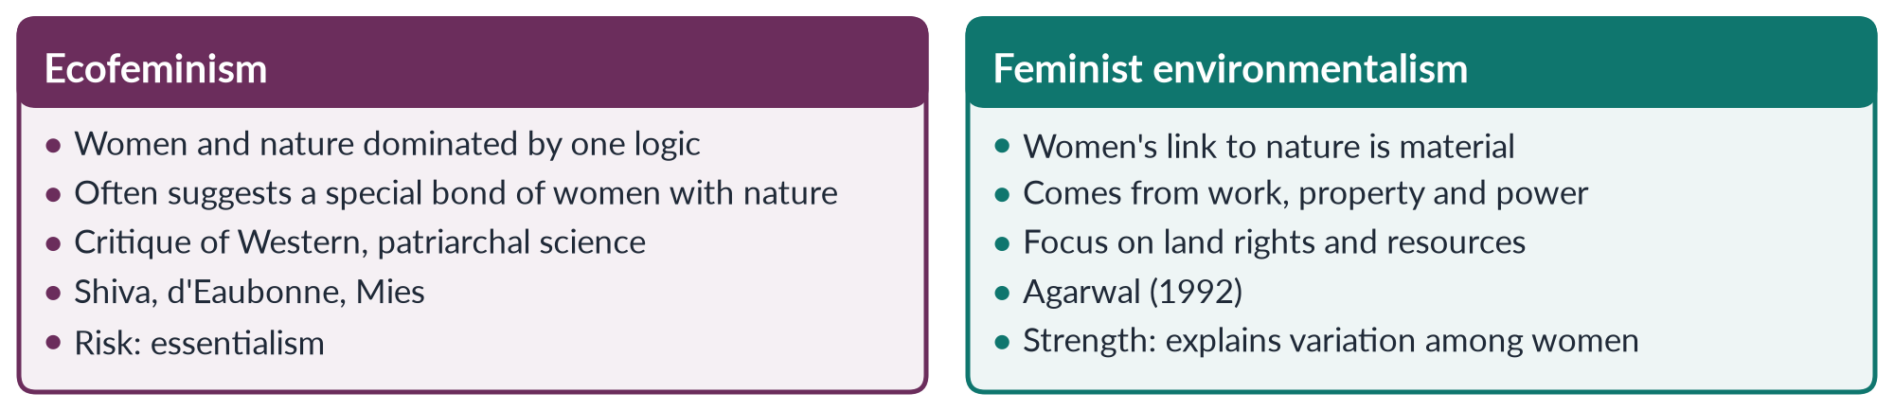
Figure 28 · Ecofeminism and feminist environmentalism.

14.3 The 2022 floods in Pakistan
✦ DATA
The 2022 floods · Government of Pakistan and UN
Monsoon floods in 2022 affected about 33 million people and killed more than 1,700; about a third of the country was under water at the peak. The Post-Disaster Needs Assessment estimated damage and losses of about 30 billion dollars. UNFPA estimated about 650,000 pregnant women were in flood-affected areas.

How the floods affected women differently:
1. Maternal health. Hundreds of thousands of pregnant women lost access to clinics and safe delivery; many gave birth in camps without skilled help.
2. Privacy and safety in camps. Lack of separate toilets, bathing spaces and lighting exposed women and girls to harassment and violence; many avoided eating and drinking to avoid using open latrines.
3. Menstrual hygiene. Lack of sanitary supplies and water caused health problems.
4. Livelihoods. Women lost livestock (often their main asset), kitchen gardens and home-based work; they had little land or savings to fall back on.
5. Relief access. Relief was often registered to male heads of household or required a national identity card (CNIC), which many rural women lacked; women-headed households struggled to get aid.
6. Care burden. Women cared for sick children and elders amid disease outbreaks (malaria, diarrhoea, skin infections).
7. Girls' education. Schools were destroyed or used as shelters; girls were more likely to drop out.
8. Early marriage. Reports from relief agencies suggested some families married daughters early to reduce costs or for "protection" — a known pattern after disasters.
9. Mobility and warnings. Restrictions on women's movement and lower phone ownership limited access to warnings and evacuation.

14.4 Heat waves
Pakistan is one of the world's most heat-exposed countries; Jacobabad in Sindh is regularly among the hottest cities on earth, with extreme heat in May–June.
- Women doing cooking over open fires in poorly ventilated kitchens, and field work (cotton picking, harvesting) face high heat stress.
- Pregnant women face higher risks of complications and pre-term birth.
- Water collection becomes harder and longer as sources dry up.
- Cultural norms on dress and mobility can make it harder for women to reach cooler spaces.
- Home-based workers in hot, crowded homes lose income when they cannot work.

14.5 Critical analysis
BALANCED VIEW · WHAT THE TWO PERSPECTIVES EXPLAIN — AND MISS
• Ecofeminism explains the common logic of exploiting nature and women, and gives moral force to women's leadership in environmental protection. But it risks essentialism — suggesting all women share one natural bond with nature — and romanticises rural women's burdens.
• Feminist environmentalism better explains why particular women suffer more: those without land, savings, CNICs, mobility or voice. It points to practical policy: land rights, cash transfers to women, women's participation in disaster management.
• Intersectionality adds that poor, rural, landless, minority and disabled women suffered most in 2022 — not all women equally.
➜ The best answer uses both: ecofeminism for the critique of destructive development; feminist environmentalism for explaining and solving women's particular vulnerability.

14.6 Global and national frameworks
- Beijing Platform (1995), critical area K: women and the environment.
- UNFCCC: the Lima Work Programme on Gender (2014) and the Gender Action Plan (2017), later enhanced.
- Sendai Framework for Disaster Risk Reduction (2015): women's leadership in disaster planning.
- Pakistan: the National Climate Change Policy (2012, updated 2021) and a Climate Change Gender Action Plan (2022); the National Disaster Management Authority has a Gender and Child Cell; BISP cash transfers to women were used for flood relief.
- Climate justice: Pakistan produces less than 1% of global greenhouse emissions but suffers some of the worst impacts; the "loss and damage" fund agreed at COP27 (2022) was pushed partly by Pakistan's experience.

14.7 What should be done
1. Sex-disaggregated data on disaster impacts.
2. Women in disaster management — at NDMA, provincial authorities and village committees.
3. Women-friendly relief — separate toilets, lighting, female staff, sanitary kits, maternal care.
4. Cash to women through BISP; help with CNIC registration.
5. Land and asset rights so women can recover.
6. Early-warning systems that reach women (phones, Lady Health Workers).
7. Climate-resilient livelihoods for women — heat-safe work, water near homes.
8. Protect girls' education and prevent early marriage after disasters.

Chapter 15 · From the MDGs to the SDGs: The Global Goals and Pakistan
MCQs ask which goal targets gender equality (SDG 5), which item was not an MDG, and about a South Asian meeting on SDGs and women (Kathmandu, 2017). This chapter gives you the global goals and Pakistan's record.

15.1 The Millennium Development Goals (2000–2015)
The Millennium Declaration (September 2000) led to eight Millennium Development Goals for 2015:
Table 11 · The eight MDGs.
No. | Goal
1 | Eradicate extreme poverty and hunger
2 | Achieve universal primary education
3 | Promote gender equality and empower women (main target: eliminate gender disparity in primary and secondary education)
4 | Reduce child mortality
5 | Improve maternal health
6 | Combat HIV/AIDS, malaria and other diseases
7 | Ensure environmental sustainability
8 | Develop a global partnership for development

Criticism from a gender angle: MDG 3 focused narrowly on education parity; it left out violence against women, unpaid care, property rights and reproductive rights (added only later as a target under MDG 5). A 2025 MCQ asked which option was not an MDG — "equal political participation of women" was not one of the eight goals (though women's share of parliamentary seats was an indicator under MDG 3).
Pakistan and the MDGs: Pakistan missed most MDG targets, including those on primary education, gender parity and maternal mortality.

15.2 The Sustainable Development Goals (2015–2030)
The 2030 Agenda for Sustainable Development, adopted in September 2015, set 17 SDGs and 169 targets, with the promise to "leave no one behind". Unlike the MDGs, they apply to all countries, and gender equality is both a stand-alone goal and a theme across the others.
✦ DEFINITION
SDG 5 · the gender goal
"Achieve gender equality and empower all women and girls." (MCQ 2026: the SDG that specifically targets gender equality is SDG 5.)

Table 12 · The targets of SDG 5.
Target | Content
5.1 | End all forms of discrimination against women and girls
5.2 | Eliminate all forms of violence against women and girls, including trafficking and sexual exploitation
5.3 | Eliminate harmful practices such as child, early and forced marriage and female genital mutilation
5.4 | Recognise and value unpaid care and domestic work
5.5 | Ensure women's full participation and equal leadership in political, economic and public life
5.6 | Universal access to sexual and reproductive health and reproductive rights
5.a | Equal rights to economic resources, land and property
5.b | Use technology, especially ICT, to empower women
5.c | Adopt and strengthen policies and laws for gender equality

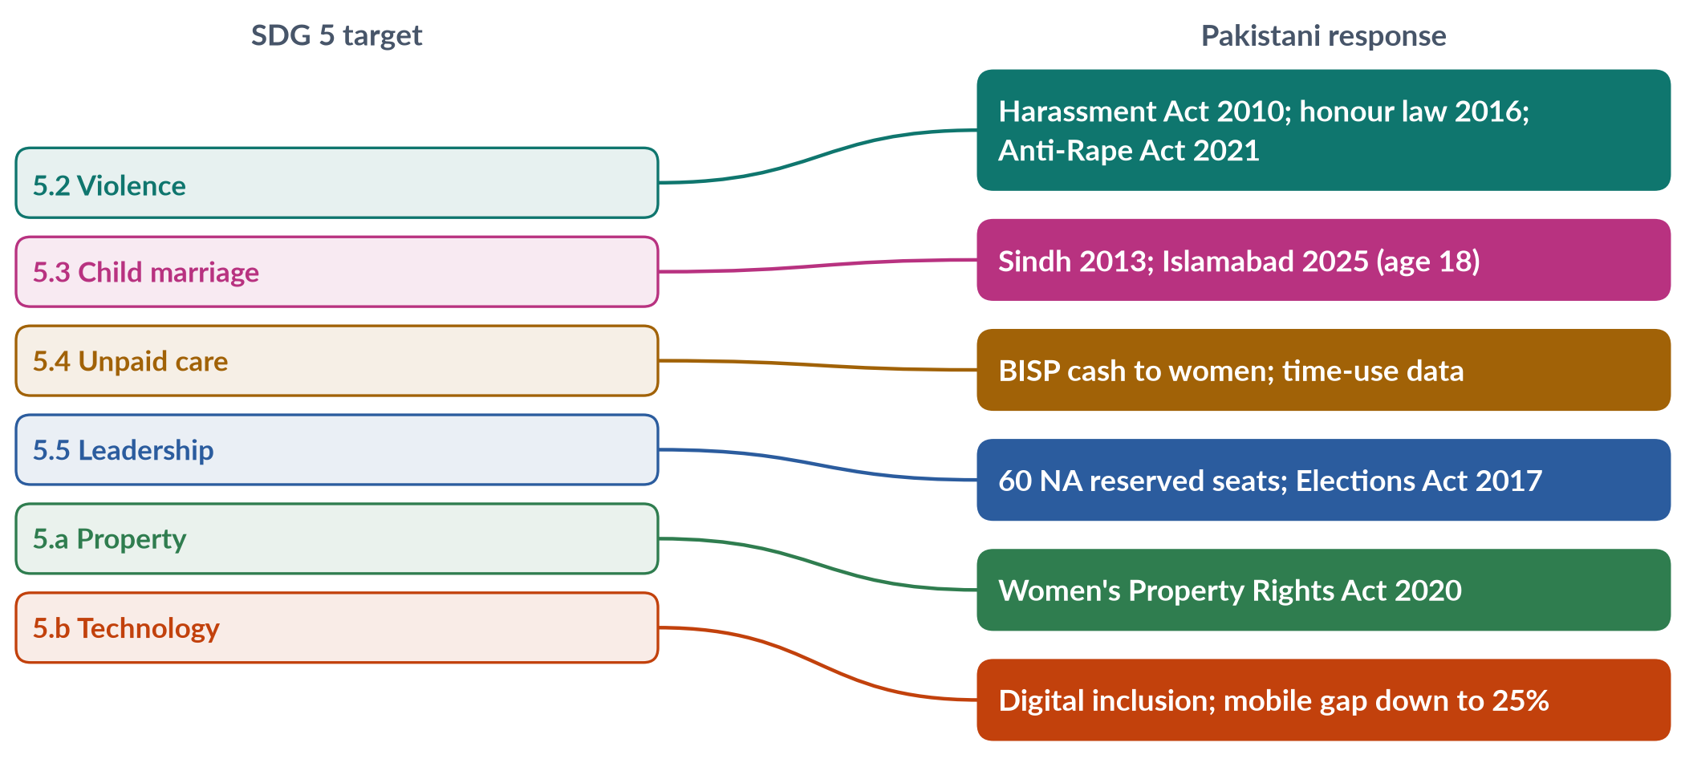
Figure 29 · How SDG 5 targets connect to Pakistani laws and programmes.

15.3 Pakistan and the SDGs
- In February 2016 the National Assembly unanimously adopted the SDGs as Pakistan's national development agenda — one of the first parliaments to do so. SDG support units were set up federally and in the provinces.
- A regional meeting of South Asian stakeholders on SDGs and women was held in Kathmandu in 2017 (MCQ 2018).
- Progress on SDG 5 is slow: Pakistan ranked 143rd of 145 on the Global Gender Gap Index (2026); female labour-force participation is 24.4%; the maternal mortality ratio was 186 per 100,000 live births (2019); child marriage remains common in many areas.
- Positive steps: new laws (2020–2025), BISP, girls' enrolment gains, women's rising use of mobile phones.

15.3a Gender across the other SDGs
Gender equality is not only in SDG 5. Other goals have gender targets or depend on women:
- SDG 1 (poverty) — equal rights to economic resources and social protection;
- SDG 3 (health) — maternal mortality and reproductive health;
- SDG 4 (education) — equal access to all levels of education;
- SDG 6 (water and sanitation) — attention to the needs of women and girls, who collect most water;
- SDG 8 (decent work) — equal pay for work of equal value;
- SDG 13 (climate) — women's role in climate planning;
- SDG 16 (peace and justice) — ending violence and inclusive decision-making.
This "gender across the goals" approach is gender mainstreaming applied to the global agenda.

15.4 Assessment of the goals approach
BALANCED VIEW · HAVE GLOBAL GOALS HELPED WOMEN?
• Yes: they created targets, data and attention; they pushed governments to report; MDG 3 helped close gender gaps in primary schooling in many countries; SDG 5 is far broader.
• But: goals are voluntary; many countries, including Pakistan, lack data; targets on violence, unpaid care and property are hard to measure; financing is short; and the COVID-19 pandemic (2020–21) set back progress. UN Women reports suggest that, at current rates, full gender equality under SDG 5 will not be reached by 2030.
➜ Goals help most when domestic politics — women's movements, legislators, courts — use them to press governments.

EXAMINER'S EYE · USING THIS CHAPTER
Use SDG 5 and its targets in any Topic 4 conclusion: they turn a critique into a policy agenda. Link each recommendation to a target (5.2 violence, 5.4 unpaid care, 5.a land). Examiners reward answers that end with concrete, internationally anchored policy.

Part Two — Today's Debates
Topic 4's newest questions join theory to the present — coloniality (2024), gendered globalisation (2025), climate (2026). These are the live debates. Each gives you facts, both sides and a line to take.

Debate 1 · Is "smart economics" smart for women?
The World Bank's World Development Report 2012 argued that gender equality is "smart economics": it raises growth. Governments and companies now promote women's work, loans and entrepreneurship on these grounds.
- For: the argument persuades finance ministries that otherwise ignore women; it has brought money to girls' education and women's enterprise.
- Against: it values women as instruments of growth, not rights-holders; it adds paid work without reducing unpaid care; it ignores violence, power and collective organising (Chant and Sweetman, 2012).
- Line to take: use the economic case to open doors, but ground policy in rights and redistribution of care.

Debate 2 · The care economy — should unpaid work be counted and paid?
LATEST UPDATE · CARE ON THE AGENDA
The COVID-19 pandemic (2020–21) showed that economies collapse without care work, most of it unpaid and done by women. SDG target 5.4 asks states to "recognise and value unpaid care and domestic work". Feminist economists call for the "3 Rs": recognise (count it through time-use surveys), reduce (through water, energy and childcare services) and redistribute (between women and men, and from families to the state).
➜ For Pakistan: workplace day-care, paid parental leave, piped water and clean cooking fuel would free women's time and raise participation above 24.4%.

Debate 3 · IMF austerity and women in Pakistan
Pakistan's 2024 IMF programme requires higher energy prices and taxes and tight spending. Critics say indirect taxes and price rises fall hardest on poor women who manage household budgets; defenders say stabilisation is necessary and BISP protects the poorest. Line to take: gender-assess each programme; protect health, education and BISP; prefer progressive taxes (Chapter 12).

Debate 4 · Microfinance: empowerment or debt trap?
Microfinance lends small sums, mostly to women, for small businesses. Supporters (the Grameen model) say it builds income and confidence; critics say loans are often controlled by husbands, used for consumption, and create debt stress with high interest rates. Kabeer's research shows effects depend on context: loans empower when combined with groups, training and markets.

Debate 5 · Platform work and artificial intelligence
Online freelancing, ride-hailing and e-commerce offer women home-based and flexible income — attractive where mobility is restricted. But platform work is insecure, unprotected and exposed to online harassment, and automation may replace routine jobs held by women (garment work, data entry, call centres). The debate asks whether digital work will widen or narrow gender gaps. Line to take: close the digital gap (25%), extend social protection to platform workers, train women in digital skills.

Debate 6 · Climate justice and women
Pakistan contributes less than 1% of global emissions but suffered the 2022 floods. The loss and damage fund (COP27, 2022) is meant to help. The gender debate asks whether climate finance will reach women — through cash transfers, land rights and women's leadership — or be captured by men and elites (Chapter 14).

Debate 7 · Is development coloniality?
The 2024 thesis (Chapter 3): development as the continuation of colonial power through experts, debt and Western models. Line to take: development must be decolonised, not abandoned — owned by local people, especially women, and focused on power.

Debate 8 · Can Pakistan raise women's labour-force participation?
Women's participation is 24.4%, far below Bangladesh. The barriers: unsafe transport, harassment, lack of childcare, social norms on mobility, low wages, and jobs concentrated in male-dominated sectors. Proposals: women-only and safe transport (such as pink buses in some cities), day-care, enforcement of the 2010 harassment law, home-based and digital work with protection, and recognising unpaid care.

Part Three — The Examiner's Record of Topic 4

Every question, 2016–2026
Table 13 · Every question the examiner has set on T4, 2016–2026.
Year · Q | The question (as set) | Family
2016 · Q8 | Critically review the Gender and Development approaches: (i) Women in Development (WID), (ii) Women and Development (WAD), and (iii) Gender and Development (GAD). | WID, WAD and GAD
2017 · Q6 | 'Powerful forces of globalization have highlighted various gender issues across cultures and throughout the globe.' Discuss by quoting examples from developing countries. | Globalisation and gender
2017 · Q8(b) | Short note: Gender and development | WID, WAD and GAD
2018 · Q6 | In the last two decades, globalization has had a huge impact on the lives of women in developing nations, including Pakistan. What are the impacts of the global political economy on Pakistani women? | Globalisation and gender
2018 · Q8(a) | Short note: Gender Strategic Needs and Gender Practical Needs | Practical and strategic gender needs
2019 · Q4 | Explain the relevance of Modernization Theory and Dependency Theory to gender equality. Critically analyze the subordination of women in modern societies in the light of these two theories. | Modernisation (and dependency) theory; Gender analysis of development theories
2019 · Q5 | The process of globalization has connected nations worldwide and made the world a global village, yet it has also increased inequalities across nations. Discuss the gendered inequalities created and promoted by globalization in contemporary societies worldwide. | Globalisation and gender
2019 · Q8(c) | Short note: Structural Functionalism | Structural functionalism
2020 · Q3 | How did the colonial era influence the status of women in the subcontinent? | Colonial and capitalist perspectives of gender
2021 · Q6 | Modernization Theory blames internal cultural factors for women's subordination in the developing world. Discuss and elaborate the statement in respect of Modernization perspectives. | Modernisation (and dependency) theory
2021 · Q7 | Critically analyze the various approaches to women's development, focusing on Women in Development (WID), Women and Development (WAD), and Gender and Development (GAD). | WID, WAD and GAD
2022 · Q7 | What are the capitalistic perspectives of gender? Explain. | Colonial and capitalist perspectives of gender
2022 · Q8 | Discuss in detail the gender critique of Structural Adjustment Policies (SAPs). | Gender critique of Structural Adjustment Policies
2023 · Q6 | Write a detailed note on the colonial and capitalistic perspectives of gender. | Colonial and capitalist perspectives of gender
2024 · Q3 | Write a note on the colonial and capitalistic perspectives of gender. Throw light on the thesis that development is the new name of coloniality in the context of emerging perspectives of gender. | Colonial and capitalist perspectives of gender
2024 · Q5 | Give a critical gender analysis of development theories. | Gender analysis of development theories
2025 · Q3 | Critically evaluate the concept of 'gendered globalisation', focusing on World-System Theory and how the globalisation of capitalism has created new forms of patriarchal power that increase gender inequalities. | Globalisation and gender; Gender analysis of development theories
2025 · Q7 | Critically analyze Women in Development (WID) and Gender and Development (GAD) models. Discuss their basic principles and limitations in addressing women's needs in developing countries. | WID, WAD and GAD
2026 · Q5 | Climate change has gendered impacts. Drawing on feminist environmentalism and ecofeminist perspectives, critically analyse how recent floods and heat waves in Pakistan have affected women differently. | Gender, climate change and ecofeminism

What the record reveals
- The heaviest topic: 16 full questions and 3 short notes (17.5 visits), and at least one question every year from 2016 to 2026. It also supplies 17 of the 140 MCQs.
- Four strong families. WID/WAD/GAD (2016, 2017 note, 2018 note on needs, 2021, 2025); colonial and capitalist perspectives (2020, 2022, 2023, 2024 — four years running); globalisation (2017, 2018, 2019, 2025); development theories (2019, 2019 note, 2021, 2024, 2025).
- Critique is the command. "Critically review", "critically analyse", "critical gender analysis", "critically evaluate". Description alone cannot score well.
- The questions join theory to the present. Development as coloniality (2024); gendered globalisation with world-system theory (2025); climate change, floods and heat waves (2026).
- Near repeats. WID/WAD/GAD in 2016 and 2021; colonial and capitalist perspectives in 2023 and 2024.
- Never asked in full: world-system theory alone, gender mainstreaming, practical versus strategic needs as a full question, the SDGs, the care economy.

Five likely questions
1. "Explain world-system theory. How does it explain the position of women in the global economy?" (Chapter 6.)
2. "Distinguish between practical gender needs and strategic gender interests. Why does the distinction matter for development planning in Pakistan?" (Chapter 11.)
3. "What is gender mainstreaming? Critically evaluate its achievements since Beijing 1995." (Chapter 11.)
4. "Assess the gendered impact of IMF-supported stabilisation programmes on women in Pakistan." (Chapter 12.)
5. "Unpaid care work is the hidden foundation of the economy. Discuss with reference to feminist economics." (Chapters 3 and 12; Part Two.)
These are not solved here; the Prediction Papers include answers to predicted questions. Plan each as an answer map for practice.

Part Four — The One-Liner Bank
About 125 one-liners in the style of the past MCQs. Each is a complete, checkable fact: the key word is in bold green and the date in bold navy. Read them aloud; cover the bold words and test yourself; then attempt every past MCQ below.

The one-liners

A · Development and its measures
1. The "development era" is often dated from US President Truman's "Point Four" speech of 20 January 1949.
2. Mahbub ul Haq created the UNDP Human Development Report in 1990: development means "enlarging people's choices".
3. Amartya Sen wrote Development as Freedom (1999) — development as expanding capabilities.
4. GDP ignores unpaid care and subsistence work, most of it done by women.
5. Marilyn Waring showed in If Women Counted (1988) that national accounts make women's work invisible.
6. The HDI measures health, education and income — it is not a gender index.
7. UNDP introduced the GDI and GEM in 1995 and the Gender Inequality Index (GII) in 2010.
8. The World Economic Forum's Global Gender Gap Index began in 2006.
9. Pakistan ranked 143rd of 145 in the Global Gender Gap Report 2026, and 144th on economic participation.
10. The World Bank's World Development Report 2012 called gender equality "smart economics".
11. Chant and Sweetman (2012) criticised smart economics for treating women as instruments of growth.
12. In 1968 Mahbub ul Haq said Pakistan's wealth was concentrated in about "22 families".

B · Colonial perspectives
13. James Mill (History of British India, 1817) used women's status as the measure of civilisation.
14. Katherine Mayo's Mother India (1927) was called by Gandhi "a drain inspector's report".
15. Spivak (1988): "White men are saving brown women from brown men."
16. Lata Mani showed women were the "ground", not the subjects, of the sati debate.
17. Sati was banned by the Bengal Sati Regulation of 1829.
18. The Hindu Widows' Remarriage Act was passed in 1856.
19. The Indian Penal Code (1860) remains the base of Pakistan's criminal law.
20. The Criminal Tribes Act (1871) labelled hijras a criminal class.
21. The Punjab Laws Act (1872) made custom the first rule, so many Muslim women lost Islamic inheritance.
22. The Age of Consent Act (1891) raised the age for girls from 10 to 12.
23. The Child Marriage Restraint Act ("Sarda Act") was passed in 1929.
24. Colonial land settlements recorded land in the names of male heads of households.
25. Partha Chatterjee (1989) described the nationalist division of life into an outer material and an inner spiritual world guarded by women.

C · Capitalist perspectives and coloniality
26. Engels (1884) linked women's subordination to private property.
27. Industrial capitalism created the public/private split and the male breadwinner model.
28. Maria Mies (Patriarchy and Accumulation on a World Scale, 1986) coined "housewifisation".
29. Mies studied the lace makers of Narsapur, India.
30. Silvia Federici (Caliban and the Witch, 2004) linked early capitalism to the witch-hunts.
31. Aníbal Quijano (2000) distinguished colonialism from coloniality of power.
32. María Lugones (2007) described the coloniality of gender.
33. Arturo Escobar wrote Encountering Development (1995), a post-development critique.
34. Wolfgang Sachs edited The Development Dictionary (1992).
35. Chandra Mohanty's "Under Western Eyes" (1984) criticised the image of the "Third World woman" as victim.
36. The Ali Enterprises factory fire in Karachi (11 September 2012) killed about 260 workers.

D · Modernisation theory
37. W. W. Rostow wrote The Stages of Economic Growth: A Non-Communist Manifesto (1960).
38. Rostow's five stages: traditional society, preconditions, take-off, drive to maturity, high mass consumption.
39. Modernisation theory blames internal cultural factors — tradition — for women's subordination (2021 question).
40. Daniel Lerner wrote The Passing of Traditional Society (1958).
41. Inkeles and Smith wrote Becoming Modern (1974).
42. Modernisation assumed benefits would "trickle down" to women through the family.
43. Ester Boserup (Woman's Role in Economic Development, 1970) showed modernisation often marginalised women farmers.
44. Boserup contrasted female farming systems (hoe) with male farming systems (plough).
45. In Pakistan the Green Revolution of the 1960s gave machines and credit mainly to male landowners.

E · Dependency and world-system theory
46. Raúl Prebisch argued that the South's terms of trade decline (the Prebisch–Singer thesis).
47. Andre Gunder Frank coined "the development of underdevelopment" (1966).
48. Walter Rodney wrote How Europe Underdeveloped Africa (1972).
49. Cardoso and Faletto described "dependent development" (1969).
50. The UN called for a New International Economic Order in 1974.
51. The gender critique of dependency theory: it is gender-blind and ignores local patriarchy.
52. World-System Theory was developed by Immanuel Wallerstein (MCQ 2019) in The Modern World-System (1974).
53. Wallerstein divided the world into core, semi-periphery and periphery.
54. Smith and Wallerstein (1992) showed that households' unpaid work lets employers pay below a living wage.
55. Fuentes and Ehrenreich (1983) described the global assembly line.
56. Kathryn Ward (1990) brought women workers into world-system analysis.
57. Gendered globalisation means globalisation relies on and reshapes gender inequality (2025 question).
58. The Rana Plaza collapse in Bangladesh (24 April 2013) killed more than 1,100 garment workers.

F · Structural functionalism
59. Structural functionalism is related to the stability of society (MCQ 2019).
60. Émile Durkheim and Talcott Parsons are the main functionalist thinkers.
61. George Murdock (1949) named four functions of the family: sexual, reproductive, economic, educational.
62. Parsons and Bales (1955): men play the instrumental role, women the expressive role.
63. Robert Merton added manifest and latent functions and dysfunctions.
64. The main gender critique: functionalism justifies inequality and ignores power and conflict.
65. Ann Oakley studied housework as real work in The Sociology of Housework (1974).

G · WID
66. The concept that women have an important role in the development process is WID (MCQ 2019).
67. The term WID was coined by development professionals based in Washington (MCQ 2018).
68. The Percy Amendment (1973) required US aid to integrate women.
69. USAID created an Office of Women in Development in 1974.
70. WID drew on liberal feminism and modernisation theory.
71. The approach that takes the sexual division of labour for granted is WID (MCQ 2024).
72. WID was criticised mainly for failing to transform gender relations (MCQ 2026).
73. WID's projects were criticised as "add women and stir".
74. Pakistan's Women's Division was created in 1979; the First Women Bank opened in 1989.

H · WAD
75. WAD (late 1970s) holds that women were always in development, but on unequal, exploitative terms.
76. WAD drew on Marxism and dependency theory.
77. The IDS workshop on "The Continuing Subordination of Women" was held in 1978.
78. WAD's main weakness: it stressed class and ignored patriarchy within classes.
79. The 2026 question on NGO-isation asked candidates to use the WAD critique.

I · GAD, needs and empowerment
80. GAD (1980s) focuses on gender relations of power between women and men.
81. GAD focuses on "all of these" — gender relations, power and roles (MCQ 2025).
82. DAWN was founded in Bangalore in 1984; Sen and Grown presented its platform at Nairobi (1985).
83. Maxine Molyneux (1985) distinguished practical and strategic gender interests.
84. Caroline Moser turned them into practical and strategic gender needs (1989, 1993).
85. Practical gender needs address immediate necessities (MCQ 2026) — water, food, health.
86. Strategic gender interests aim to change women's position — land, laws, power.
87. Moser's triple role: productive, reproductive and community-managing work.
88. Moser's five policy approaches: welfare, equity, anti-poverty, efficiency, empowerment.
89. The author of Reversed Realities (1994) is Naila Kabeer (MCQ 2018).
90. Kabeer (1999): empowerment is the ability to make strategic life choices — resources, agency, achievements.
91. Transforming grassroots women from beneficiaries to active participants is empowerment (MCQ 2023).
92. Sara Longwe's framework: welfare, access, conscientisation, participation, control.
93. The Harvard Analytical Framework (1985) maps activities and access to and control over resources.
94. The first global framework to adopt gender mainstreaming was the Beijing Declaration (1995) (MCQ 2024).
95. ECOSOC defined gender mainstreaming in 1997.
96. A benefit of gender mainstreaming: "all of these" (MCQ 2025).
97. "All women are organised for an equitable share of development" is an incorrect statement (MCQ 2023).

J · Structural adjustment
98. The debt crisis broke out when Mexico could not pay in 1982.
99. John Williamson coined "Washington Consensus" in 1989.
100. SAP conditions: spending cuts, subsidy removal, user fees, devaluation, privatisation, liberalisation.
101. Diane Elson (Male Bias in the Development Process, 1991) said SAPs treat women's labour as "infinitely elastic".
102. UNICEF's Adjustment with a Human Face was published in 1987.
103. The Commonwealth's Engendering Adjustment for the 1990s appeared in 1989.
104. Poverty Reduction Strategy Papers followed in 1999.
105. Pakistan's first IMF adjustment programme began in 1988; a 7-billion-dollar EFF was approved in 2024.

K · Globalisation
106. The growing interdependence of societies across the world is globalisation (MCQ 2023).
107. Giddens: globalisation is "the intensification of worldwide social relations which link distant localities".
108. The WTO was founded in 1995.
109. Guy Standing described the feminisation of labour (1989).
110. Arlie Hochschild described global care chains (2000).
111. Naila Kabeer's The Power to Choose (2000) studied Bangladeshi garment workers.
112. The Atlanta Agreement (1997) moved Sialkot's football stitching into centres; many women homeworkers lost work.
113. The EU's GSP+ for Pakistan (from 2014) requires 27 conventions including CEDAW.
114. Sindh passed Pakistan's first Home-Based Workers Act in 2018.
115. Pakistan's remittances reached a record of more than 38 billion dollars in 2024–25.

L · Climate and the global goals
116. Françoise d'Eaubonne coined ecofeminism in 1974.
117. Vandana Shiva wrote Staying Alive (1988).
118. Bina Agarwal (1992) proposed feminist environmentalism: women's link to nature is material.
119. The 2022 floods affected about 33 million Pakistanis, including about 650,000 pregnant women (UNFPA).
120. Pakistan emits less than 1% of global greenhouse gases.
121. The loss and damage fund was agreed at COP27 (2022).
122. The Lima Work Programme on Gender was adopted in 2014; the UNFCCC Gender Action Plan in 2017.
123. The MDGs (2000) had 8 goals; MDG 3 was gender equality.
124. The SDGs (2015) have 17 goals and 169 targets; the gender goal is SDG 5 (MCQ 2026).
125. SDG target 5.4 asks states to recognise and value unpaid care work.
126. Pakistan's National Assembly adopted the SDGs as its national agenda in February 2016.

Every past MCQ on Topic 4
Table 14 · Every recovered MCQ on T4, with its key.
Year | Question | Key
2018 · 13 | The South Asian convention on SDGs and women referenced in the paper was held in: | D - Kathmandu, 2017
2018 · 15 | Professionals associated with coining WID (Women in Development) were based in: | B - Washington
2018 · 16 | Author of Reversed Realities: | A - Naila Kabeer
2019 · 3 | Structural Functionalism is related to the ____ of society. | A - Stability
2019 · 4 | Who developed World-System Theory? | B - Immanuel Wallerstein
2019 · 19 | The concept that women have an important role in the development process is: | A - WID
2019 · 20 | Generalized Anxiety Disorder (GAD) is related to: | A - Social life (published key; the wording is broad)
2023 · 3 | Which statement regarding gender-based inequality is incorrect? | B - All women are organized for an equitable share of development
2023 · 7 | Transformation of grassroots women from mere beneficiaries to active participants is: | D - None of these (empowerment)
2023 · 17 | Growing interdependence of societies across the world is: | A - Globalization
2024 · 11 | The first global policy framework to adopt gender mainstreaming was: | B - Beijing Declaration
2024 · 16 | Which approach takes the sexual division of labour for granted? | B - WID
2025 · 7 | Which is not a Millennium Development Goal? | C - Equal political participation of women
2025 · 13 | Gender and Development focuses on: | D - All of these
2025 · 14 | Which indicator measures gender inequality? | No single fully valid option - GDI/GEM are gender-related; HDI is not a gender-inequality measure
2025 · 15 | A benefit of gender mainstreaming is: | D - All of these
2026 · 3 | In GAD, practical gender needs differ from strategic gender interests because the former: | C - Address immediate necessities
2026 · 12 | The WID approach that emerged in the 1970s was primarily criticized for: | D - None of these; its main critique is failure to transform gender relations
2026 · 15 | Which SDG specifically targets gender equality? | D - None of these; SDG 5

TRAP · THREE MCQ TRAPS IN TOPIC 4
1. GAD the approach, GAD the disorder. A 2019 MCQ used "GAD" for Generalized Anxiety Disorder. Read the whole stem before assuming Gender and Development.
2. Who "coined" versus who "wrote". WID was coined by development professionals in Washington; Boserup wrote the founding book (1970); Kabeer wrote Reversed Realities (1994); Wallerstein developed world-system theory (1974).
3. HDI is not a gender index. The gender measures are the GDI, GEM (1995) and GII (2010).

Part Five — The Revision Sheet
The whole of Topic 4 in a few pages, for the night before the exam. Every term is explained where it appears, so you will not need to turn back to the chapters.

1. Development and why gender matters
- Development — improvement in people's lives: income, health, education, freedom, choice; not only GDP (value of goods and services produced; ignores unpaid work).
- History of the idea — Truman's "Point Four" (20 Jan 1949, "underdeveloped areas") → 1950s–60s growth and trickle-down → 1970s basic needs and the discovery of women (Boserup 1970) → 1980s structural adjustment → human development (Mahbub ul Haq, UNDP HDR 1990: "enlarging people's choices") → Sen, Development as Freedom (1999, capabilities = real freedoms) → MDGs 2000 → SDGs 2015 ("leave no one behind").
- Why gender matters — women are half the population; their unpaid work is uncounted (Waring, If Women Counted, 1988); policies are never gender-neutral; equality is a right (CEDAW, SDG 5) and also helps development (education, child health, household spending, growth); World Bank WDR 2012 "smart economics" (critics Chant and Sweetman 2012: women as instruments, not rights-holders).
- Measures — HDI (1990; not a gender index); GDI and GEM (UNDP 1995); GII (Gender Inequality Index, 2010); WEF Global Gender Gap Index (2006).
- Pakistan — GGGR 2026 143/145, 59.5%; economic 144th, education 130th, political 107th (2025: 148/148); LFPR 24.4% (LFS 2024–25); Ayub's "Decade of Development", Green Revolution; Haq's "22 families" (1968); first IMF SAP 1988; BISP 2008 (cash to women).
- Four questions of gender analysis — who works (paid/unpaid)? who owns and controls? who benefits? do gender relations become more equal?

2. Colonial perspectives of gender (2020, 2023, 2024)
- Meaning — how colonial rulers saw, judged and changed gender relations, and how the colonised responded: (1) the colonial gaze; (2) colonial policies; (3) the nationalist response.
- The gaze — James Mill, History of British India (1817): women's status = measure of civilisation, India judged low; Katherine Mayo, Mother India (1927): Indian men degenerate, women victims (Gandhi: "a drain inspector's report"); Spivak (1988): "White men are saving brown women from brown men"; Lata Mani: in the sati debate women were the "ground", not subjects; justified the "civilising mission".
- Laws — Bengal Sati Regulation 1829 (Roy); Hindu Widows' Remarriage Act 1856 (widows lost late husband's property); Indian Penal Code 1860 (adultery s. 497 punished only the man, wife as husband's property); Cantonment and Contagious Diseases Acts 1864–68 (forced examination of women); Female Infanticide Prevention Act 1870; Criminal Tribes Act 1871 (hijras); Punjab Laws Act 1872 (custom first → Muslim women lost Islamic inheritance); Age of Consent Act 1891 (10 → 12); Sarda Act 1929; Shariat Act 1937; Dissolution of Muslim Marriages Act 1939.
- Four channels — law (codified personal law with male scholars and landlords → rigid, patriarchal "tradition"; "Anglo-Muhammadan law"); land (settlements recorded land in male heads' names; women's use rights lost); economy (machine cloth destroyed women's spinning and weaving; cash crops, plantations, cantonments); education (some girls' schools; a small educated elite of women).
- Nationalist response — Partha Chatterjee (1989): outer material world (copy the West) vs inner spiritual world of home (keep "Indian"); women as guardians of the inner world; the "new woman" — educated but modest; Muslim reformers (Nazir Ahmad 1869; Mumtaz Ali 1898): education within Islamic family values → women as symbols of honour and identity.
- Assessment — gains (sati ban, remarriage, age of consent, girls' schools, 1939 divorce law) vs losses (patriarchal codification, lost inheritance and land, criminalised hijras, bodily control, women used to justify rule); reforms often from Indian reformers. Verdict: colonialism rearranged patriarchy.
- Legacy in Pakistan — PPC 1860; Sarda Act until Sindh 2013 / ICT 2025; low land ownership and customary denial of inheritance; stigma of khawaja siras; women as symbols of identity.

3. Capitalist perspectives and "development as coloniality" (2022, 2023, 2024)
- Capitalism — private ownership, markets, wage labour, profit. Two perspectives: liberal/market (jobs and income free women; remove barriers; smart economics) vs critical/socialist-feminist (capitalism depends on and deepens subordination).
- Critical ideas — Engels 1884 (private property → control of women's sexuality → "world historical defeat of the female sex"); industrial capitalism's public/private split, separate spheres, male breadwinner; unpaid labour/social reproduction (Benston 1969; Dalla Costa and James 1972); women as cheap, flexible labour / reserve army; Maria Mies (1986) — "housewifisation" (defining women as housewives to cheapen their work; lace makers of Narsapur); Federici, Caliban and the Witch (2004) — witch-hunts and early capitalism.
- Pakistan — home-based workers (Sindh HBW Act 2018); textiles and the Ali Enterprises fire (Karachi, 11 Sept 2012, ~260 dead); cotton pickers; unpaid care; LFPR 24.4%.
- Colonial + capitalist linked — colonialism was capitalist expansion (East India Company); both created the public/private split; both extracted value from women's cheap or unpaid work; both used "civilisation/progress" to justify power.
- Coloniality — Aníbal Quijano (2000): colonialism (formal rule, ended) vs coloniality (continuing patterns of power in race, economy, knowledge); María Lugones (2007): coloniality of gender — European binaries and male-headed households imposed.
- Post-development — Escobar, Encountering Development (1995); Sachs, The Development Dictionary (1992): development as a discourse that defines the South as "underdeveloped" and makes Western experts the authorities.
- Thesis applied to gender — the "Third World woman" as victim (Mohanty 1984); outside experts set agendas; debt and conditions (SAPs, IMF); extraction via supply chains; Western gender models imposed.
- Counter-argument — vaccines, schools, lower maternal and child deaths; Southern ownership (Haq; DAWN 1984); women themselves demand education and rights. Line: development must be decolonised, not abandoned — owned by local women, focused on power.

4. Modernisation theory (2019, 2021, 2024)
- Definition — poor countries are poor because "traditional"; they develop by following the West: industry, cities, education, democracy, modern values; obstacles are internal (culture, religion, family).
- Rostow, The Stages of Economic Growth: A Non-Communist Manifesto (1960) — traditional society → preconditions for take-off → take-off → drive to maturity → high mass consumption; aid and investment help "take-off"; a Cold War theory. Also Parsons (pattern variables), Lerner (Passing of Traditional Society, 1958), Inkeles and Smith (Becoming Modern, 1974).
- On women — tradition oppresses, modernity frees; benefits trickle down through the male breadwinner; women as mothers and homemakers (welfare, nutrition, family planning); Western nuclear family as model.
- 2021 statement — correct as description: modernisation located causes inside societies (culture, purdah, honour, parents' attitudes, traditional values); cure = education, media, urbanisation, Western values.
- Gender critique — Boserup (1970): modernisation gave land, technology, training and credit to men → women farmers marginalised; female (hoe) vs male (plough) farming systems; blames culture and ignores structures (colonial history, trade, land, state); West has its own patriarchy (new forms: housewife ideal, beauty industry, double burden); trickle-down failed within households; "tradition" often colonial or changing; ignores women's agency.
- Still relevant — education, cities, media and paid work do widen choices; some cultural practices are real obstacles (child marriage, honour killing, inheritance denial). Weakness: culture as the only cause, West as the only model.
- Pakistan — Ayub era (1958–69), Green Revolution (machines, credit to male landowners; poor women lost farm work), MFLO 1961 as a modernising reform; today girls' education and phones widen options but LFPR stays 24.4% → structures matter.

5. Dependency theory
- Definition — poverty is produced by colonialism and unequal exchange; the rich centre extracts from the periphery; underdevelopment is a result, not a stage.
- Thinkers — Prebisch (ECLA, 1950; Prebisch–Singer thesis: falling terms of trade for raw materials); Andre Gunder Frank ("development of underdevelopment", 1966); Walter Rodney (How Europe Underdeveloped Africa, 1972); Samir Amin (delinking); Cardoso and Faletto (1969, "dependent development").
- Policy — import-substituting industrialisation; protection; planning; South–South cooperation; New International Economic Order (UN, 1974).
- Offers gender analysis — structures not culture; colonial history; explains cheap (increasingly female) labour; links gender to class.
- Gender critique — gender-blind (nations and classes, not women and men); women's unpaid subsistence work subsidises cheap exports (Mies); ignores local patriarchy; male nationalist industrial models; "Asian tigers" grew by export-led growth relying on young women's labour.
- Feminist uses — "double dependency" (country on centre; women on men); Helen Safa on Latin American women workers.
- Pakistan — cotton and textiles; cotton pickers; IMF debt limits social spending; but feudal land, custom and mobility limits also matter.

6. World-system theory and "gendered globalisation" (2025)
- Wallerstein, The Modern World-System (1974; MCQ 2019) — one capitalist world-economy since the 1500s; core (rich, finance, technology), semi-periphery (both exploiter and exploited), periphery (raw materials, cheap labour); surplus flows via unequal exchange; differs from dependency by one system, the semi-periphery and long history.
- Gender extensions — Smith and Wallerstein (1992): households combine wages with unpaid work, so employers pay below a living wage — women's unpaid labour fills the gap; Mies (1986): exploitation of nature, colonies and women; global assembly line (Fuentes and Ehrenreich 1983); Kathryn Ward (1990).
- Gendered globalisation — globalisation relies on, reshapes and often deepens gender inequality, while creating some opportunities.
- New forms of patriarchal power — corporate/workplace patriarchy (low wages, surveillance, harassment); feminisation of labour (Standing 1989: flexible, informal, low-paid); global care chains (Hochschild 2000); debt and austerity; commodification of bodies (trafficking, surrogacy, beauty industry); cultural backlash.
- Evidence — harm: Rana Plaza (Bangladesh, 24 April 2013, 1,100+ dead, mostly women); Ali Enterprises (2012). Gains: first independent income for millions of women; later marriage; bargaining power (Kabeer, The Power to Choose, 2000).
- Evaluation — globalisation creates opportunities and new patriarchal controls; effect depends on labour rights, state policy, women's organising; theory risks portraying women as passive and underplays local patriarchy and agency.
- Pakistan — periphery/lower semi-periphery (textiles, cotton, rice; external finance); women at bottom of chains; male Gulf migration; remittances record 38+ billion dollars (2024–25); EU GSP+ (2014; 27 conventions incl. CEDAW).

7. Structural functionalism (2019 note)
- Definition — society as a system of interrelated parts (family, education, religion, economy, government), each with a function keeping the whole stable (equilibrium). MCQ 2019: related to stability.
- Thinkers — Durkheim (shared values, division of labour); Talcott Parsons; Robert Merton (manifest, latent functions; dysfunctions); George Murdock (1949: nuclear family universal; sexual, reproductive, economic, educational functions).
- Parsons and Bales (1955) — husband-father instrumental role (breadwinner, link to society, task-oriented); wife-mother expressive role (care, emotion, socialising children); family functions: primary socialisation and stabilising adult personalities; avoids competition between spouses.
- Link to development — pattern variables → modernisation; planners treated men as producers, women as homemakers (home-economics classes; extension services to men).
- Critique — justifies inequality ("functional for whom?"); ignores power and conflict (violence, control of money); based on 1950s white middle-class America; ignores women's economic work; cannot explain change; biological assumptions. Critics: Friedan (1963), Oakley (Sociology of Housework, 1974), Marxist feminists.
- Useful — roles tied to institutions; socialisation; dysfunction (rigid roles waste talent).
- Pakistan — man as provider (kafeel), woman as homemaker in textbooks, sermons, dramas; but rural women do heavy productive work; two incomes needed; migration leaves women heads of households.

8. The theories compared (2024)
- Critical gender analysis asks: cause of poverty; where women appear; assumptions (family, work); silences; policy effects.
- Table in words — modernisation: internal tradition; women freed by modernity; critique = blames culture, men captured benefits. Dependency: external exploitation; women absent; critique = gender-blind, ignores local patriarchy and unpaid work. World-system: one unequal world economy; later households and assembly line; critique = early gender blindness, women as victims. Functionalism: incomplete modernisation; women expressive; critique = justifies inequality, ignores power.
- Shared weaknesses — gender blindness; unpaid work invisible; household as harmonious unit (vs Sen's "cooperative conflict", 1990; Agarwal's bargaining, 1997); women passive; male-centred progress.
- Responses — WID (answer to modernisation); WAD (from dependency/Marxism); GAD (socialist feminism); later: capabilities (Nussbaum 2000), post-development and decolonial, feminist economics (Waring, Elson, Folbre), ecofeminism.
- Conclusion — each theory holds part of the truth (culture, institutions, global structures); gender analysis adds power relations, unpaid work and agency, joining local and global.

9. WID — Women in Development (1970s)
- Origins — before 1970, the welfare approach (women as mothers). Boserup 1970. Term coined by women development professionals in Washington, DC (MCQ 2018). Percy Amendment 1973 (US aid must integrate women); USAID WID Office 1974; IWY 1975 and the UN Decade; women's ministries (Pakistan's Women's Division 1979).
- Principles — women left out; problem = exclusion, not the model; solution = access (education, credit, training, technology, jobs); liberal feminism; separate women's projects (MCQ 2019: women have an important role in development = WID).
- Moser's approaches of the era — equity (original WID; seen as threatening), anti-poverty (income projects), efficiency (women make development efficient; relies on unpaid time).
- Practice — sewing, handicrafts, poultry, kitchen gardens; credit; literacy and skills; appropriate technology (stoves, mills, pumps); women's units — critics: a "women's ghetto".
- Achievements — women visible in data and planning; institutions (women's ministries, the UN Decade fund later UNIFEM, INSTRAW); resources; women as producers; paved the way for CEDAW (1979).
- Limitations — accepted the development model ("add women and stir"); took the sexual division of labour for granted (MCQ 2024) → added to women's workload; women alone, not gender relations or men's power; ignored class, race, global inequality; small marginal projects in "feminine" activities; Western bias; instrumentalism. Main criticism: failed to transform gender relations (MCQ 2026).
- Pakistan — Women's Division (1979), Ministry of Women Development, vocational centres, credit schemes, First Women Bank (1989): skills and some income, but small scale; little change in land, inheritance, wages or decisions.

10. WAD — Women and Development (late 1970s)
- Origins — Marxist and dependency critics of WID; IDS Sussex workshop "The Continuing Subordination of Women in the Development Process" (1978); Southern scholars.
- Principles — women always part of development, but on unequal, exploitative terms; the problem is the nature of development — unequal international and class system; women's paid and unpaid work undervalued; strategy: women's projects plus structural change.
- Examples — EPZ jobs = integration as exploitation; cash crops (who profits? world prices? food security?); aid projects that leave debt and trade untouched. "WID says let women in; WAD says women are already in — at the bottom."
- NIEO link (1974) — fairer world economy would help Southern women; shared North–South framing later criticised for hiding conflicts between Southern women and men.
- Contributions — "development for whom?"; links to class and global inequality; values women's knowledge; Southern voice; prepared GAD and DAWN.
- Limitations — class over gender; ignored patriarchy within classes; women as homogeneous; little on household and reproductive work; women-only projects again; weak policy influence.
- Today — the lens for judging micro-credit, handicraft projects, export jobs and donor NGO projects (2026 NGO-isation question).
- Pakistan — the Hyderabad embroiderer trained by a project still sells to a middleman at piece rates, owns no land, does all housework → position unchanged; Okara (2000–) and Sindhiani Tehreek (1982–) closer to WAD's idea of change.

11. GAD, needs, roles, empowerment, mainstreaming
- Origins — 1980s socialist feminists (IDS Subordination of Women group, Kate Young); DAWN (Bangalore 1984; Development, Crises and Alternative Visions by Gita Sen and Caren Grown, Nairobi 1985); Beijing (1995) adopted mainstreaming and empowerment.
- Principles — gender relations of power, not women alone; gender socially constructed; production and reproduction, inside the household; women as agents; transformation of structures; role of the state; intersection with class and race. MCQ 2025: GAD focuses on "all of these".
- Molyneux (1985, Nicaragua) — practical vs strategic gender interests; Moser (1989, 1993) — practical and strategic gender needs.
- PGNs — immediate material needs from current roles (water, health, food, housing, fuel, income, childcare); accept division of labour; short term; welfare/anti-poverty/efficiency. MCQ 2026: they address immediate necessities.
- SGIs/SGNs — long-term interests in changing women's position (land and inheritance, laws against violence, equal wages, political power, bodily control); challenge division of labour; equity/empowerment. Example: hand pump near home (PGN) vs women's land ownership under the 2020 property law (SGN). Meeting PGNs through women's organisations can open strategic change.
- Moser's triple role — productive, reproductive, community-managing (men: productive and community-politics, paid, status). Five approaches — welfare (1950s, mothers), equity (1970s WID), anti-poverty, efficiency (1980s), empowerment (bottom-up, from the South).
- Kabeer — Reversed Realities (1994; MCQ 2018); empowerment (1999) = "expansion in people's ability to make strategic life choices where this ability was previously denied"; resources, agency, achievements. MCQ 2023: beneficiaries → active participants = empowerment. Longwe: welfare, access, conscientisation, participation, control. Harvard Framework (1985): activities, access and control.
- Gender mainstreaming — ECOSOC (1997): assessing the implications for women and men of any planned action, in all areas and at all levels; first adopted globally in the Beijing Declaration (1995; MCQ 2024); benefits "all of these" (MCQ 2025); tools: sex-disaggregated data, gender analysis, gender budgeting, audits, focal points, quotas.
- Pakistan GAD tools — Gender Reform Action Plans (2000s); gender-responsive budgeting pilots; 10% quota in federal jobs; BISP cash to women; Women's Property Rights Act 2020; laws on violence and child marriage.
- GAD limitations — hard to implement (reduced to checklists and training); "gender" can hide women; "mainstreamed away"; depoliticisation (NGO-isation); resistance from men and elites; "Western concepts?" (reply: DAWN is Southern).
- Comparison — focus: women / women and class / gender relations. Problem: excluded / unequally integrated / unequal power. Theory: liberal & modernisation / Marxism & dependency / socialist feminism. Goal: integrate / change system / transform relations. Household: not examined / little / inside, bargaining. Needs: practical / practical / practical and strategic. Women: passive recipients / exploited workers / agents. Critique: status quo / ignores patriarchy / hard to implement. Names: Boserup, Percy / IDS 1978 / Molyneux, Moser, Kabeer, DAWN.

12. Structural adjustment (2022)
- Background — debt crisis (Mexico 1982); IMF/World Bank loans with conditions; "Washington Consensus" (Williamson 1989).
- Conditions — cut spending (health, education, subsidies, public jobs); remove subsidies (food, fuel, power); user fees; devaluation; privatisation; trade and financial liberalisation; labour deregulation.
- Gender-blind — ignored the household/care economy; costs shifted to women's unpaid work. Diane Elson, Male Bias in the Development Process (1991): SAPs treat women's labour as "infinitely elastic".
- Critique — more unpaid care (sick at home, stretching food); worse women's health (fees; maternal care); girls withdrawn from school; loss of public-sector jobs (teachers, nurses); push into informal work; export jobs low-paid and insecure; food price rises; stress and violence; men lose breadwinner role; no voice for women.
- Evidence and response — UNICEF, Adjustment with a Human Face (Cornia, Jolly, Stewart 1987); Commonwealth, Engendering Adjustment for the 1990s (1989); DAWN 1985; response: safety nets, PRSPs (1999), "gender-responsive" language — core conditions little changed.
- Pakistan — first IMF SAP 1988; SBA 2023; 7-billion-dollar EFF 2024; conditions: energy prices, sales tax, development cuts, subsidy removal → women's unpaid work and budgets squeezed; BISP expanded as safety net (partial answer). Line: stabilisation may be needed but must be gender-assessed — protect health, education, BISP; progressive taxes; count care.

13. Globalisation (2017, 2018, 2019)
- Definition — growing interdependence of societies worldwide (MCQ 2023); Giddens: "intensification of worldwide social relations which link distant localities". Dimensions: economic, political, technological, cultural, human (migration). Accelerated from the 1980s; end of Cold War 1991; WTO 1995; internet.
- Highlighting gender issues (2017) — global norms and conferences (Beijing, CEDAW, SDG 5); media and #MeToo; supply-chain disasters (Rana Plaza); migration makes care visible.
- Opportunities — export jobs, first independent income (Bangladesh garments; East Asian electronics; Indian call centres; Kabeer 2000); information and mobile banking; rights norms (CEDAW, SDGs, GSP+); microfinance (Grameen 1983) and remittances; wider images of women.
- Inequalities (2019) — feminisation of labour (Standing 1989); EPZs (no unions, long hours, harassment); informal home-based subcontracting; wage gaps; global care chains (Hochschild 2000; kafala abuse); trafficking; agricultural displacement; unsafe workplaces (Rana Plaza 2013; Ali Enterprises 2012); commodification (skin-lightening creams) and backlash; inequality between countries.
- Pakistan (2018) — textiles and garments (home-based stitchers on piece rates); Sialkot's Atlanta Agreement 1997 (stitching moved to centres; women homeworkers lost work); cotton pickers and world prices; male migration and remittances (38+ billion dollars, 2024–25; women run households); IMF programmes; GSP+ 2014 (27 conventions incl. CEDAW); digital freelancing but 25% mobile gap; media and backlash; LFPR 24.4%, economic rank 144th — fewer women drawn into export jobs than in Bangladesh (mobility, transport, safety, industry structure).
- Balance — both good and bad; outcome depends on labour rights, social protection, transport and childcare, women's organisation, fair trade.

14. Climate change (2026)
- Why gendered — dependence on water, fuel, fodder; less land, savings, insurance; restricted mobility and warnings; care burdens; pregnancy and heat risks; little voice.
- Ecofeminism — domination of women and nature linked; coined by d'Eaubonne (1974); Shiva, Staying Alive (1988, "maldevelopment"); Mies and Shiva, Ecofeminism (1993); Chipko (1973); Maathai, Green Belt (1977; Nobel 2004). Risk: essentialism.
- Feminist environmentalism — Bina Agarwal, "The Gender and Environment Debate" (1992): women's relation to nature is material — work, property, power; explains variation among women; points to land rights and resources.
- 2022 floods — ~33 million affected, 1,700+ dead, a third of the country under water; damage and losses ~30 billion dollars; ~650,000 pregnant women (UNFPA). Women's impacts: maternal care lost; camp privacy and safety (toilets, lighting, harassment); menstrual hygiene; lost livestock, gardens, home-based work; relief registered to male heads or needing CNICs; care for the sick; girls out of school; early marriage reports; mobility and warnings.
- Heat waves — Jacobabad among hottest cities; cooking over open fires, field work, pregnancy risks, longer water collection, dress and mobility limits, lost home-based income.
- Critical analysis — ecofeminism: common logic of domination, moral force; but essentialist and romanticising. Feminist environmentalism: explains which women suffer (no land, savings, CNIC, mobility, voice) and policy. Intersectionality: poor, rural, landless, minority, disabled women suffered most. Use both.
- Frameworks — Beijing area K; UNFCCC Lima Work Programme on Gender (2014), Gender Action Plan (2017); Sendai Framework (2015); Pakistan National Climate Change Policy (2012, updated 2021), Climate Change Gender Action Plan (2022), NDMA Gender and Child Cell, BISP flood cash; Pakistan emits < 1% of global emissions; loss and damage fund (COP27, 2022).
- Policy — sex-disaggregated data; women in disaster management; women-friendly relief (toilets, lighting, female staff, sanitary kits, maternal care); cash to women and CNIC help; land rights; early warnings reaching women (phones, LHWs); climate-resilient livelihoods; protect girls' schooling; prevent early marriage.

15. Global goals and debates
- MDGs (2000–15) — 8 goals; MDG 3 gender equality (target: education parity); MDG 5 maternal health. Gender critique: narrow; left out violence, unpaid care, property. MCQ 2025: "equal political participation of women" was not an MDG (seats were only an indicator). Pakistan missed most targets.
- SDGs (2015–30) — 17 goals, 169 targets, universal, "leave no one behind"; SDG 5: "Achieve gender equality and empower all women and girls" (MCQ 2026). Targets: 5.1 discrimination; 5.2 violence; 5.3 child/forced marriage, FGM; 5.4 unpaid care; 5.5 leadership; 5.6 reproductive health; 5.a economic resources, land; 5.b technology; 5.c laws and policies. Gender also in SDGs 1, 3, 4, 6, 8, 13, 16.
- Pakistan — NA adopted SDGs as national agenda (Feb 2016); Kathmandu 2017 South Asian meeting (MCQ 2018); slow SDG 5 progress (143/145; 24.4%; MMR 186, 2019; child marriage); positives: laws 2020–25, BISP, girls' enrolment, mobile use.
- Assessment — targets, data and attention vs voluntary, data gaps, financing, COVID-19 setbacks; goals help when domestic movements use them.
- Debates — smart economics (opens doors vs instrumentalism); care economy and the "3 Rs" (recognise, reduce, redistribute; SDG 5.4; day-care, leave, water, clean fuel); IMF austerity (gender-assess; protect BISP); microfinance (empowerment vs debt trap; context matters — Kabeer); platform work and AI (flexible income vs insecurity and automation); climate justice (will finance reach women?); development as coloniality (decolonise, don't abandon); raising women's LFPR (safe transport, childcare, harassment law, protected home-based and digital work).

